BioPath: Tools for Biochemistry Startup Guide/Report

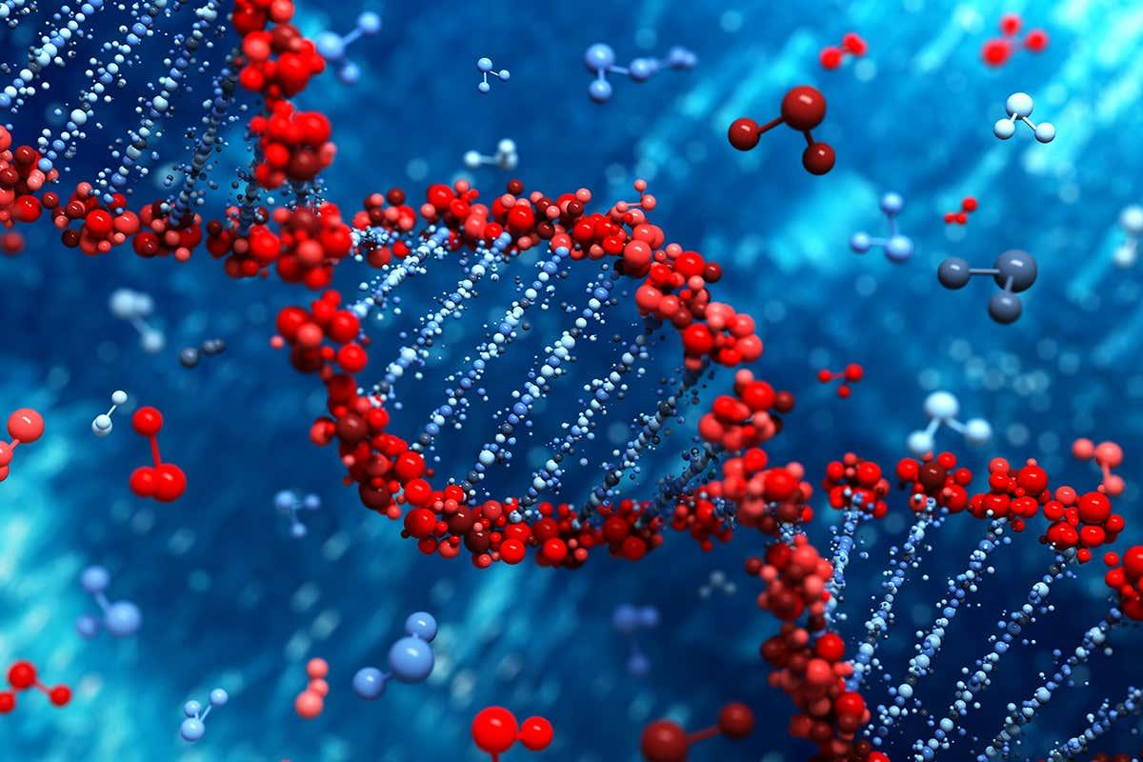

January 21, 2021

Adapted By: 2020-2021 Development Team

Started By: 2019-2020 Development Team

Contents

Where to Start for… (edited) 7

Dr. Watson and Administrators 7

Users of the Website 7

Software Developers 7

Run the Website/First Time Setup 8

Preliminaries 8

Check the type of CPU you are running 8

Installing an Environment Manager 9

Installing WSL - Windows 9

Miniconda 9

Run the Website for students 11

SSH into the server 11

Clone our Code 12

Run the Website on your Local Machine 13

Using miniconda 13

Run the Website off-site (not using GU wifi) 18

AWS Guide 19

Pathway/Model 22

Reaction 22

Substrate 22

Enzyme 22

Product 22

Co-Factors 22

Hexokinase 23

Phosphoglucose Isomerase 23

Phosphofructokinase 23

Fructose-bisphosphate Aldolase 23

Triosephosphate isomerase 23

Glyceraldehyde 3-phosphate Dehydrogenase 23

Phosphoglycerate Kinase 24

Phosphoglycerate Mutase 24

Enolase 24

Pyruvate Kinase 24

ATP 24

An Introduction to the Web App 25

HOME PAGE 25

SIGN UP 25

LOG IN 26

modelChoice 27

Admin Tools 28

Admin Tools: Add Model 28

Admin Tools: Delete User 30

Admin Tools: Delete Teacher Model 31

Admin Tools: Edit Pre-existing Model 31

Student Models 32

Student Models: Edit Model 32

Student Models: Edit Model: Create New Reaction 33

Teacher Models 35

All about Software 36

Required Software 36

Application Made With 36

Recommended Software 36

Visual Studio Code 36

Django Crashcourse 39

What is Django? 39

Key Django Concepts 40

Basic Commands 40

Testing in Django 41

User Permissions 41

Where are permissions assigned in our application? 41

Distinguishing admins from other users 42

Finding the list of permissions 42

CSS and Bootstrap 42

Bootstrap Implementation 42

What is Bootstrap? 42

How is it implemented into our application? 42

Why use bootstrap.min.css instead of bootstrap.css? 43

Modifications made to the Bootstrap files 43

Where are the Bootstrap files loaded in the application? 43

How are the Bootstrap elements called in the application? 43

Useful Bootstrap Resources: 43

Various Guides 43

Python Web Dev 43

Remote Double SSH Guide for VSC 44

The DATABASE (bum bum bumm) 44

Installing MySQL 44

Installing for Macs 44

Installing for Linux or WSL 44

Resources 45

MySQL Workbench 45

Accessing the Database 46

Overview 46

Database Credentials 46

Instructions for MySQL Workbench 46

Instructions for Terminal 46

Create a new Linear Pathway (without branches or cycles) 47

Creating or Restoring a Backup 49

Creating a backup of the database 49

Restoring the database from a backup 49

Copying the database locally 49

Write to the Database Backend with Django 50

Entity-Relation Diagram 51

6. Overview of the Code 53

Important Frontend Files 53

Django Files 53

Manage.py 53

Settings.py 53

Urls.py 54

Views.py 54

Models.py 54

JavaScript, HTML, and CSS Files 54

Templates 54

Static 54

Javascript Files 55

modelEdit.js 55

drawPathway.js 55

moduleEdit.js 55

modelChoice.js 56

addModel.js 57

main.js 57

Adding a new webpage to the app 57

Mobile Support 59

Important Concepts 59

CSS Media Rules 59

Bootstrap 59

Implementation 59

Helpful Resources 60

Google Sign in 60

modelEdit.js 64

Summary 64

Data Fields (in order of appearance) 64

Functions 66

Current Bugs 68

Mobile to Desktop mode in a web browser 68

Scaling of Images 69

Other 69

Future Work (Suggestions) 70

Graphics 70

Pathways 71

Database 74

Miscellaneous 74

BioPath: A History… + resources 75

2018-2019 75

2019-2020 Developers 76

2020-2021 Developers 76

Important Account Information 76

# Where to Start for… (edited)

BioPath (we also refer to it as BioTools) is a web application with the purpose of serving as a tool to assist students in learning about biochemical pathways. The current iteration of BioPath includes animations depicting chemical pathways inside the body and how the various elements inside those pathways interact with each other. It has been moved to AWS for ease of access, can be used on any devices outside of campus, and can somewhat display circular pathways.

## **Dr. Watson and Administrators**

For Dr. Watson and other administrators: to run the website please login to AWS using the credentials provided. To get to where the website can be run, monitored or modified just follow the instructions provided in the AWS Guide provided.

## **Users of the Website**

Go to Part 3 for an overview of the Website.

## **Software Developers** Ideally, you are going to want to read and understand as much of this as possible. It is best if you go through this report linearly. Odds are, you don’t.

You only need to download one environment manager. We all (Hailey Mueller, Daniel Strubb, Brandon Clark and Sean Letts) used the terminal (with WSL) in VS Code as their environments because it was easy to change the code and run the website to test it.

So, depending on your preference you can probably skip 1B. If you do you will need to install Bash or WSL before starting at the beginning.

Ideally all group members have taken Database Management Systems or took it in the Fall. However, if only 1 or 2 of you have done this you should be fine. If no one has taken it well… good luck and have fun learning

Bradon Clark used Miniconda as his environment manager (he was on a Mac and Windows, what an epic gamer).

In some places the guides have only been tested on a Mac OS, in others just on Windows 10 OS. We tried to include guides and all steps for both but bear in mind that there might be some steps we forgot to include. It’s possible you run into errors that we didn’t as well. Let your preferred search engine and Stack Overflow be your guide in these cases – they treated us not too bad.

We assume that you have at least a working knowledge of how to use git.

“I” terminology in this report refers to any of the 2020-2021 software developers

# Run the Website/First Time Setup



## **Preliminaries**

### Check the type of CPU you are running

When installing applications, it is important to know what type of a processor you are running. There are two options; either a 64 or 32 bit version.

For Windows:

1. Type System in the search bar and click “System Information”

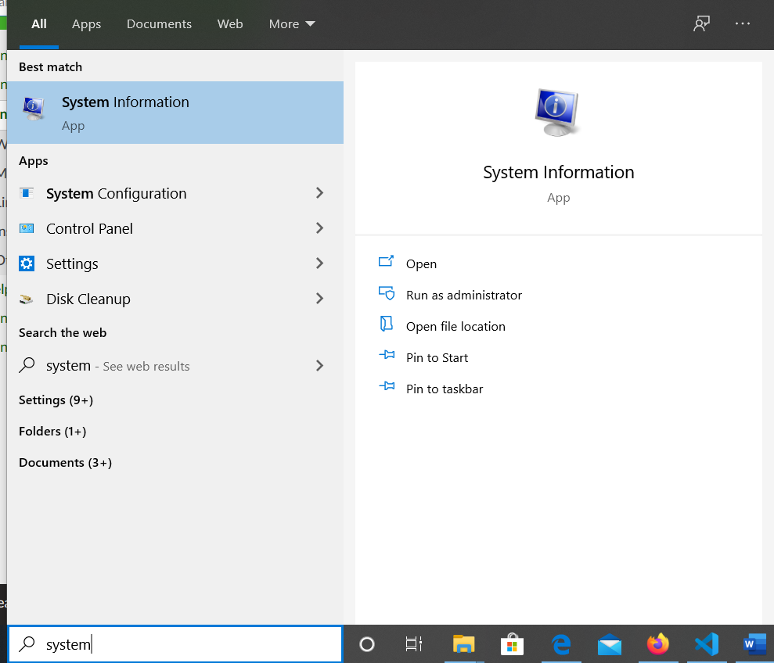

1. Your processor type can be found by “System Type”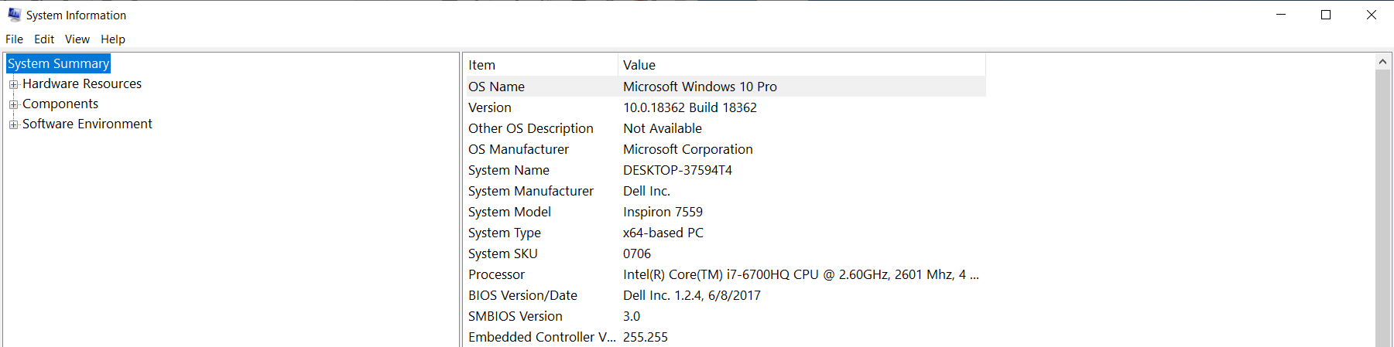

For Macs:

1. Click the Apple icon in the top-left corner of your screen
2. This will open a drop-down menu. Pick the top option: About This Mac
3. A window with your system information should open up

### Installing an Environment Manager

For running the website for students:

If you have Windows 10, go to step “a. Installing WSL”.

If you have a Mac OS you can skip this step (TODO: check if it is possible to ssh into ada thru terminal)

For running the website just on your local machine go to step: “b. Installing Miniconda” – if you have a Windows 10 and already have WSL I suggest going to 1B.

#### Installing WSL - Windows

1. Check if you already have WSL or Bash installed: go to your search bar and type: cmd [enter]
   1. The command prompt should open. Type: bash [enter]
   2. If the following appears, you have WSL/bash installed and can skip to 1B.



1. If you do not have WSL or Bash installed go [here](https://www.computerhope.com/issues/ch001879.htm) and follow the steps for installing WSL.

#### Miniconda

(Example using Windows 10)

1. Go to the following [Website](https://docs.conda.io/en/latest/miniconda.html):
2. Install Python Version 3.7
   1. NOTE: If you have a different OS install miniconda for your OS

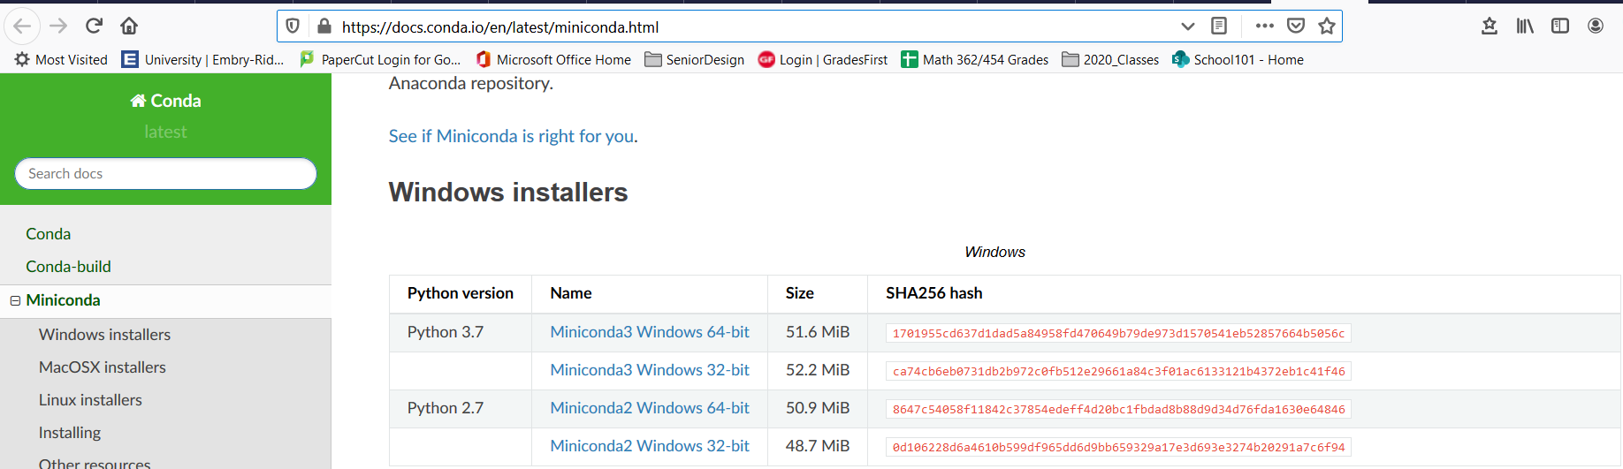

* 1. Click the version you want to install. It should start downloading automatically. Once it is finished downloading double click the .exe to run the downloader

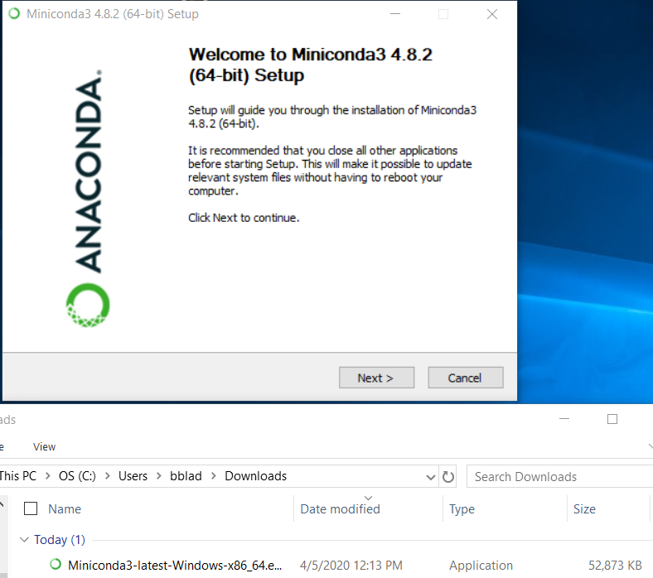

* 1. Follow the setup guide steps
     1. No need to check the boxes below if you do not want to.

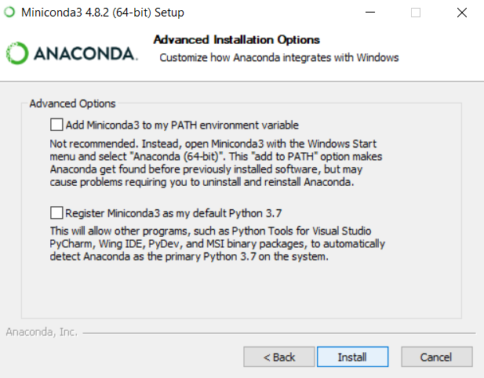

## **Run the Website for students**

### SSH into the server

1. Open terminal (for macs), WSL, Bash, or some other UNIX based shell program.
   1. FOR SOFTWARE DEVELOPERS: Contact Jason Schnagel. Jason helped us set up the Gonzaga server for us to host our BioPath application. You will need to contact him to relaunch the one we were working on. The database should also be on this server. You also need him to give your GU account the correct permissions to run off the server so that other people on GU’s wifi can access the website. This is assuming you want to run it on the gonzaga’s server and not host it yourself.
2. In the shell program, type: ssh ada.gonzaga.edu [enter] and input the correct user account information for yourself

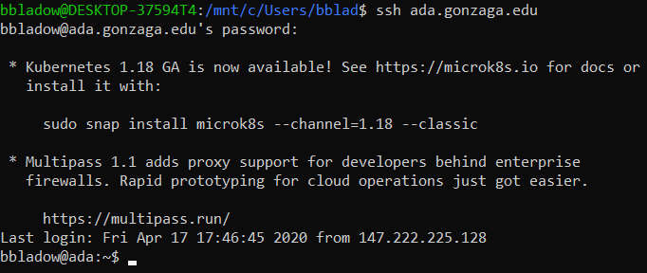

1. Now type ssh igt4-biochem.gonzaga.edu [enter] and input the correct user account information for yourself. If you have the correct permissions and typed your password in correctly you should see something like the following:

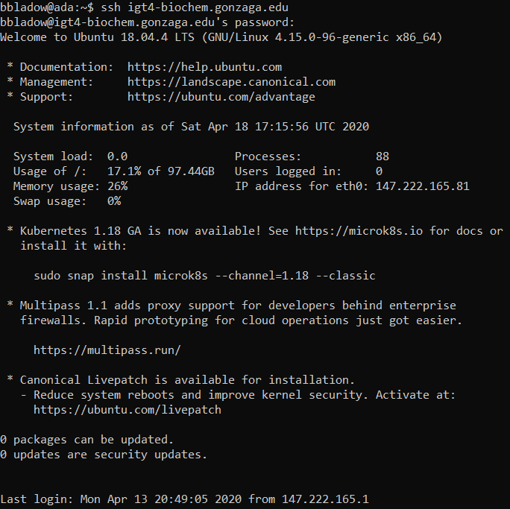

### Clone our Code

I am assuming git has already been installed for your access to the server. Because we used a private repository this year you might need to request access from Zach McKee to be allowed to clone the code. You will need a github account

1. Type: git clone [name of github repo given to you] [enter] while on the server

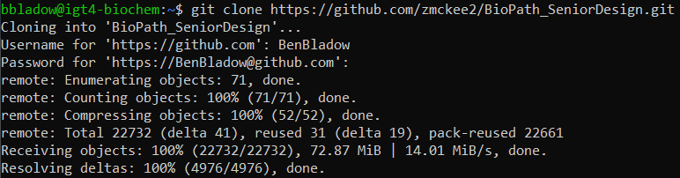

1. Type: cd BioPath_SeniorDesign [enter] to go into the directory of code.

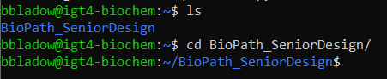

1. You should be on the master branch. Now type: source seniorProjenv/bin/activate [enter]
2. Next type: python3 manage.py runserver 0.0.0.0:8080 [enter] to run the website on the server
   1. You might need to install pip3 and python3 before being able to run the server.
   2. You shouldn’t run into the following error but you might. If you do, it is because of how the settings.py file for Databases is configured



* + 1. It should look like this:

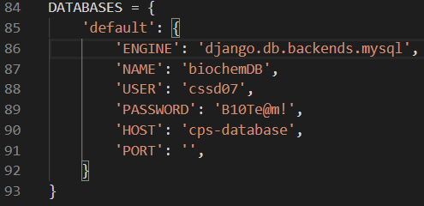

1. Now type igt4-biochem.gonzaga.edu:8080 into any web browser and as long as you are on campus wifi you should have access!

## **Run the Website on your Local Machine**

Note: You will still need to be on campus wifi because you have not yet cloned the database. Also, the following is a guide for miniconda but the process is similar for WSL or bash. You need to download the correct software (python3, pip3, mysqlclient), clone the code, activate the environment – for WSL use the source command, and run it – runserver command.

### Using miniconda

1. Run the application, Anaconda Prompt. It should look like a black screen that you can type on.

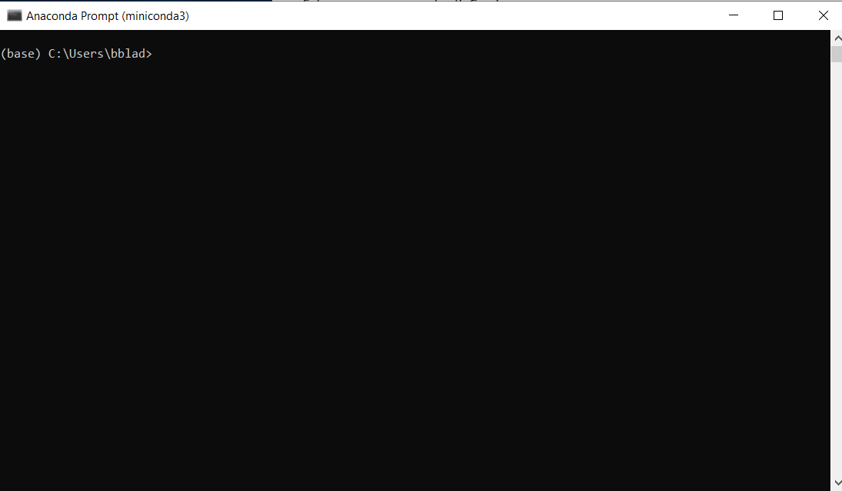

1. Type: conda create -- name biopath [enter]

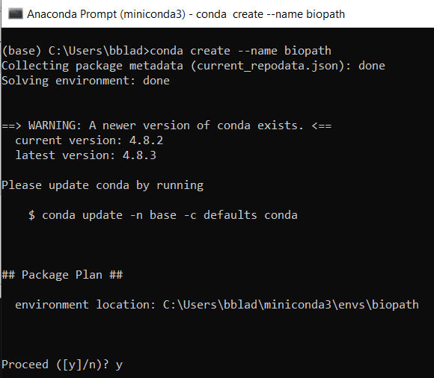

* 1. It will then ask you if you wish to proceed. Type: y [enter]
  2. Next type: conda activate biopath [enter]

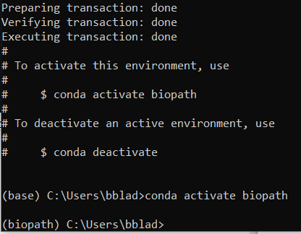

1. Install git if you do not have it installed already by typing:
   1. Conda install -c anaconda git [enter]
2. Navigate to the directory you wish to have the code stored and clone the repo
   1. type: git clone https://github.com/zmckee2/BioPath_SeniorDesign.git [enter]

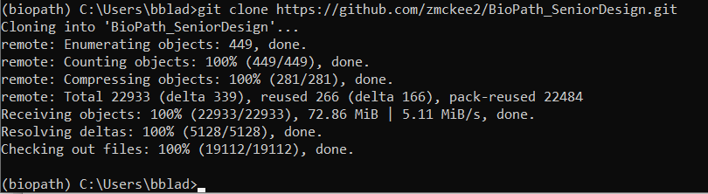

* 1. After cloning our code it would be a great idea to have a developer setup their own private (private for security reasons, we have a database with information we would not want leaked) gitub repository for all current developers. That way all developers will be able to push and change the code.

1. Navigate to the directory in your downloaded repo where requirements.txt is:

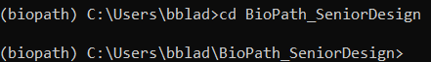

* 1. You can do this with the cd <directory_name> [enter] command
     1. If you cloned the repo in some other location on the computer there are 2 ways to get there.
        1. Navigate through your C or D drive with: cd .. [enter] to go up a folder and: cd <directory_name> [enter] to go into a folder
        2. Use cd <entire_path_name> [enter] The path name is usually something like c:/Users/bblad/Documents/gitHubFolders/BioPath_SeniorDesign
     2. You can use the command: dir (or ls on mac) [enter] to show what files and folders are in the place you are currently in.
     3. 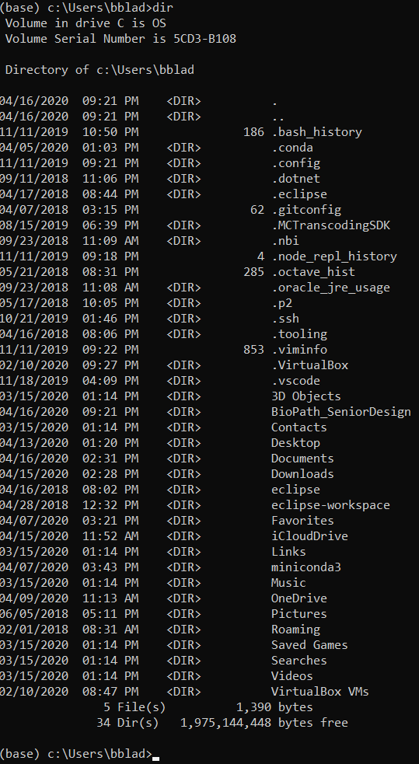

1. Install required components

You will need to install a package manager for python code named ‘pip’

1. Type: conda install -c anaconda pip [enter]
   1. This will also install other packages like python! (Needed for next steps)

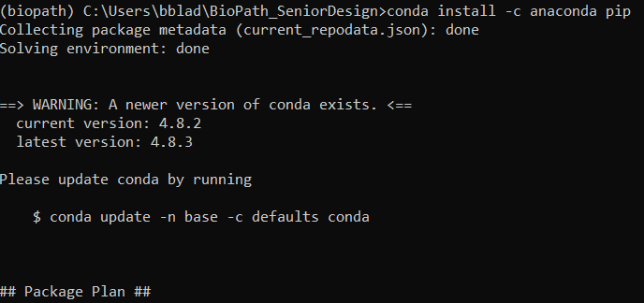

1. It will ask you if you want to proceed. Type: y [enter]

To install the required components type: pip install -r requirements.txt [enter]

Note: Depending on OS might need to use the command pip3 instead of just pip

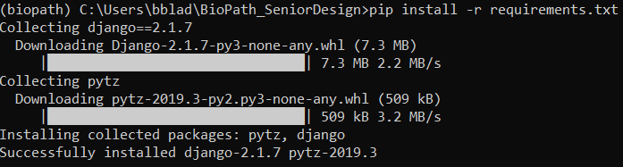

1. Now you need to install mysqlclient. Type: pip install -U mysqlclient [enter]
   1. You might need to type pip3 instead of pip

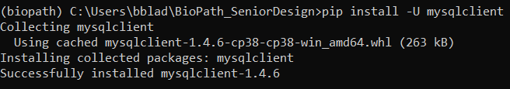

1. Contact Jason Schnagel. Jason helped us set up the Gonzaga server for us to host our BioPath application. You will need to contact him to relaunch the one we were working on. The database should also be on this server. You also need him to give your GU account the correct permissions to run off the server so that other people on GU’s wifi can access the website
2. Before running the server, check if you have all the correct packages. This can be done by running the command: python manage.py check [enter] You might need to type python3 instead of python
   1. If it works you will get the output: 
3. Once no issues are been detected type: python manage.py runserver 0.0.0.0:8080[enter]
   1. You might need to type python3 instead of python

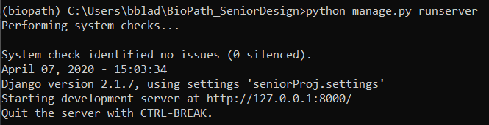

* 1. IF you get an error and do not see the above output it is most likely because of the settings.py code stored in BioPath_SeniorDesign\seniorProj
  2. Change this code

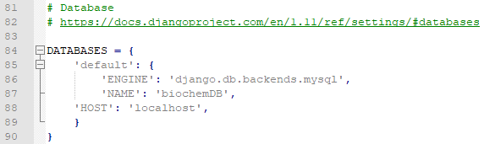

TO

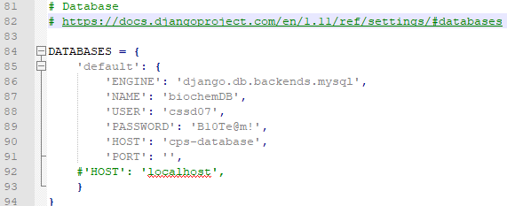

1. To view the website go to igt4-biochem.gonzaga.edu:8080 as the address in your web browser.
   1. You can also access it by typing localhost:8080 (this only works on the computer that is hosting the website)

You will need to do steps 2b and 10 every time you open conda in order to run the server. You will probably also need to navigate to the correct directory where the code is stored as well.

Possible Errors:

1. When we first tried to install the repository, we got this error:  
   “mysqlclient 1.3.13 or newer is required; you have 0.9.3”
   * We solved this by going back to a previous version of Django: pip install Django==2.1.7 🡪That is currently what is in the requirements.txt file
2. If python3 or pip3 doesn't work for Conda, use python or pip. You can also check the version of Python running by just entering python or python3 into the terminal.

## **Run the Website off-site (not using GU wifi)**

You will need to follow most of step 5. Most importantly, follow 5E III. We suggest you read through all of step 5 before attempting to copy the database locally. You will need to clone the database onto your local machine and have your own version of the code on your local machine.

You will also need to git clone the code locally and run it locally either via WSL or Miniconda.

## **AWS Guide**

1. Go to <https://aws.amazon.com/lightsail/> and select My Account then AWS Management Console.

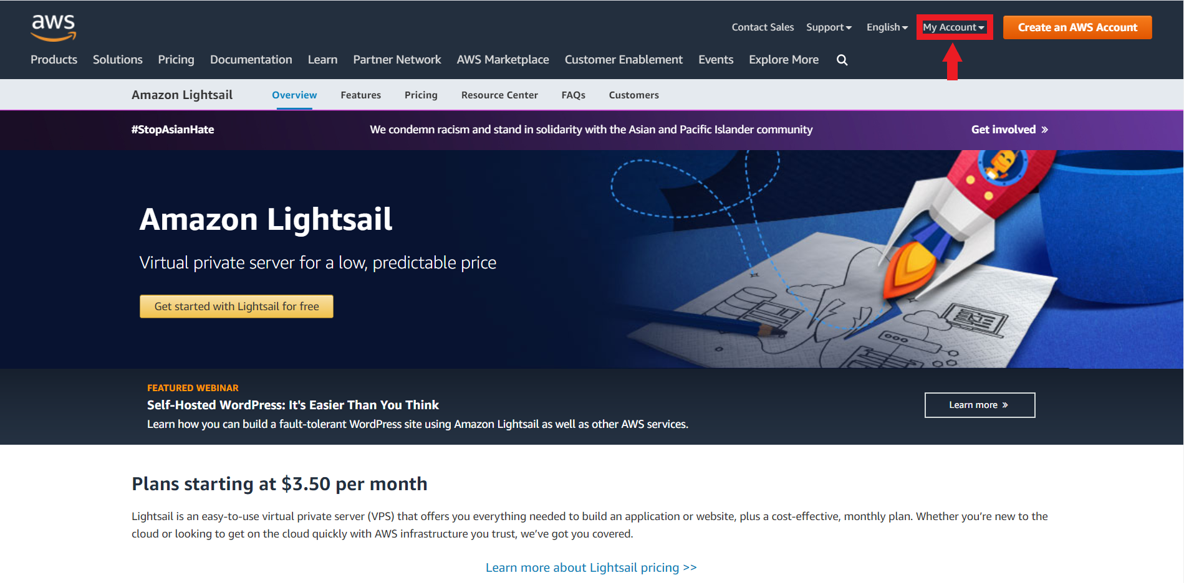

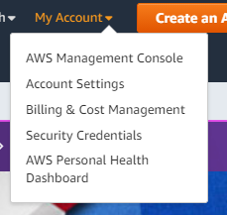

1. It should take you to the login page. Select Root User then enter in the gmail address that has been provided (should be the same as the one on the screen right now)

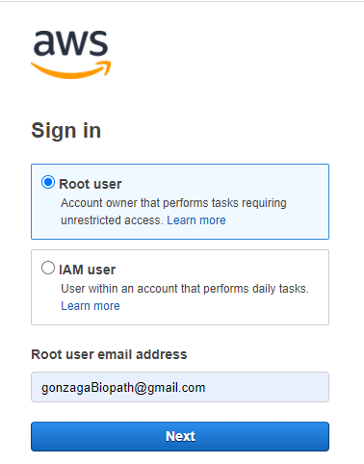

1. In the top left hand corner there should be a services drop down. Select it.

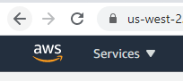

1. Select Lightsail under Computer within All Services. Alternatively you can use the search bar to find Lightsail as well.

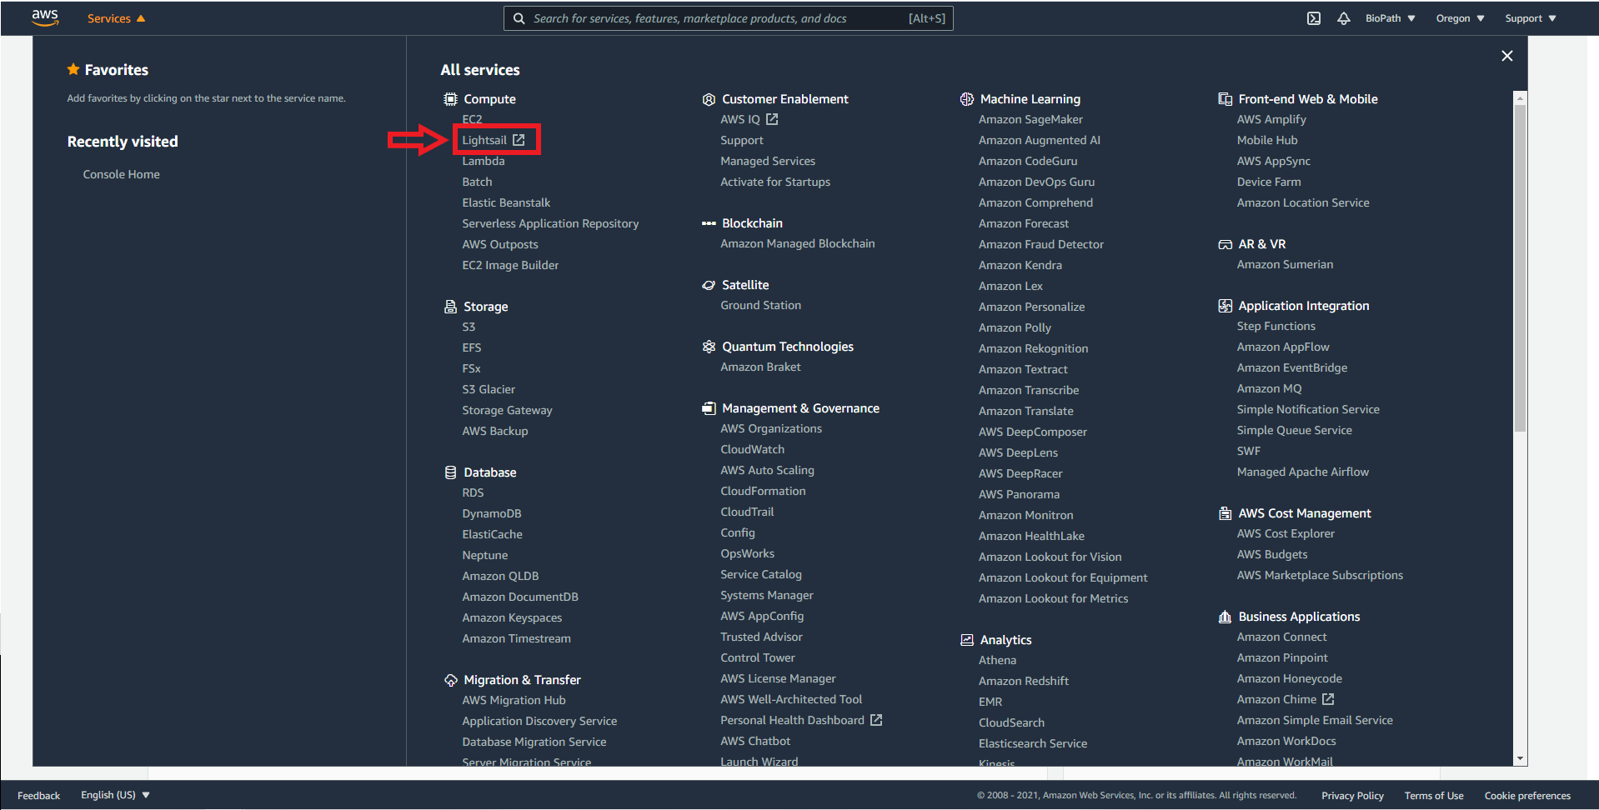

1. Once on this page you should select Biopath, as that is the already made project with a connected website url.

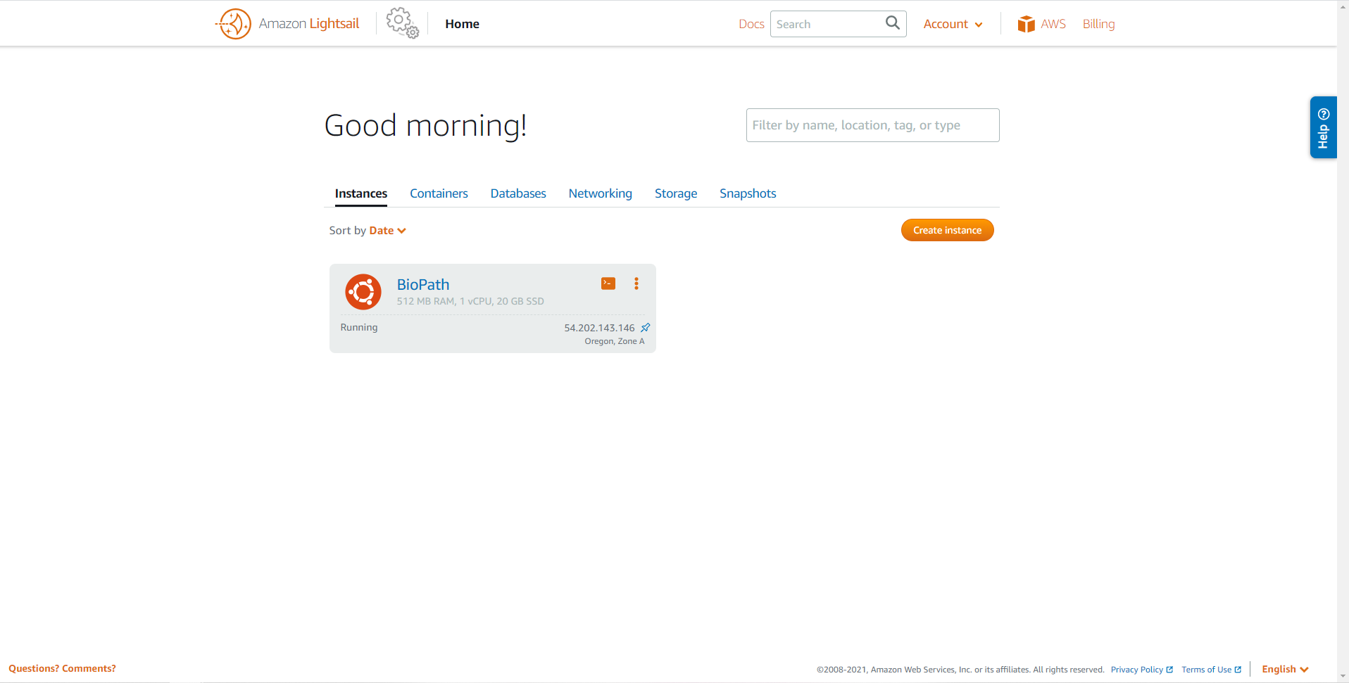

1. From this page you can stop or reboot the website or connect in with ssh through a browser client. All data can be accessed from this point.
2. After launching the terminal By clicking on “Connect Using SSH” enter the following commands to access files:
   1. cd ..
   2. cd biopathadmin

This will give you access to any of the files used in running the website on AWS.

Points of interest on AWS Lightsail:

Stop: Shuts off the server.

Reboot: Restarts the server. Think of it in a similar vein to the restart option on your computer.

Delete: Deletes the instance. DO NOT DO THIS

Connect Using SSH: Opens a terminal in your browser for the Lightsail Server. If you do this you need to run “cd ..” in the console in order to access the biopathadmin folder which contains the data for the biopath project.

Storage: Tells you how much space is available. We have plenty, it should be fine with 20 GBs of space. If there is not enough space, then perhaps it is time to upgrade the service.

Metrics: Shows how much data is being used. If, once the website is running fully, it reaches a consistent 100% CPU usage and users experience consistent slow downs or disconnects from the website then perhaps it is a good time to upgrade the service.

Networking: Shows the IP address. Can be useful if you want to implement new security features or to ssh from a remote location without using the terminal built in.This is where the ports are opened for ssh, http, and https.

2. Biochemistry Information



### Pathway/Model

A pathway is a linked set of chemical reactions that occur within a cell.

### Reaction

In 2018-2019’s group they alternatively referred to reactions as modules. We have tried staying away from calling reactions modules. A reaction is a of viable (occurs in real life) products/enzyme/substrates.

### Substrate

The input molecule upon which an enzyme acts on.

### Enzyme

The catalyzer for the chemical reaction. Takes substrate(s) as input and outputs product(s).

### Product

The output of chemical reactions. Output from an enzyme.

### Co-Factors

These are things like ATP, ADP, NAD+, NADH, H2O. They are freely floating around in the cell and therefore it is not near as important to display flow of these through reactions.

It is not vital to really understand the following. We included it because the 2018-2019 group wrote it and presumably was planning on using it. The following are vocabulary terms for the definition textbox in BioPath (except for co-factor).

### Hexokinase

a-D-Glucose + ATP à Glucose-6-phosphate (G6P) + ADP

The first step in glycolysis where a phosphate group is added to glucose using ATP. This reaction is important for its ability to trap glucose within the cell. Whereas glucose can easily traverse the plasma membrane, the negatively charged phosphate group prevents G6P from crossing, so cells can stock up on glucose while levels are high. This reaction is highly regulated, with G6P providing a feedback inhibition of the enzyme, thereby preventing excessive stockpiling until glycolysis depletes G6P levels.

### Phosphoglucose Isomerase

Glucose-6-phosphate (G6P) à Fructose-6-phosphate (F6P)

Phosphoglucose isomerase (PGI) is the second step in glycolysis that catalyzes the interconversion of G6P and F6P during glycolysis and gluconeogenesis. The shift of the carbonyl oxygen from the C1 position in G6P to the C2 position in F6P is necessary in order to add another phosphate group at the C1 position in a later reaction. This is a multi-functional enzyme that moonlights as neuroleukin.

### Phosphofructokinase

Fructose-6-phosphate (F6P) + ATP à Fructose-1,6-bisphosphate (F1,6PP) + ADP

The third step in glycolysis is another priming reaction, adding a second phosphate group to F6P. This reaction is unidirectional, committing the cell to glycolysis, as opposed to energy storage, or producing a different sugar. A different enzyme, fructose bisphosphatase, is required to catalyze the reverse reaction. The cellular levels of phosphofructokinase (PFK) and fructose bisphosphatase help drive metabolism towards glycolysis or gluconeogenesis, respectively.

### Fructose-bisphosphate Aldolase

Fructose-1,6-bisphosphate (F1,6PP) à dihydroxyacetone phosphate (DHAP) + Glyceraldehyde-3-phosphat

This enzyme is the fourth step in glycolysis that catalyzes the reversible cleavage of F1,6PP to two triose phosphates, both of which continue through glycolysis. There are two classes of aldolases, which have different catalytic mechanisms: class I enzymes are found in animals, do not require a metal ion, and are characterized by the formation of a Schiff base intermediate between an active site lysine and a substrate carbonyl group, while the class II enzymes are produced in bacteria and fungi, and require an active-site divalent metal ion. Isozymes are found for each class of enzyme, and in vertebrates the genes encoding each isozyme show tissue-specific expression.

### Triosephosphate isomerase

Dihydroxyacetone phosphate (DHAP) à Glyceraldehyde-3-phosphate (G3P)

The fifth step in glycolysis, Triosephosphate isomerase (TIM) catalyzes the reversible interconversion of G3P and DHAP. Only G3P can be used in glycolysis, therefore TIM is essential for energy production, allowing two molecules of G3P to be produced for every glucose molecule, thereby doubling the energy yield.

### Glyceraldehyde 3-phosphate Dehydrogenase

Glyceraldehyde-3-phosphate (G3P) +NAD+ + Pi à 1,3-Bisphosphoglycerate (1,3BPG) + NADH + H+

Glyceraldehyde-3-phosphate dehydrogenase (GAPDH) is in the second phase of glycolysis, plays an important role in glycolysis and gluconeogenesis by reversibly catalyzing the oxidation and phosphorylation of G3P to the energy-rich intermediate 1,3BPG. NAD+ is a co-substrate for this reaction. GAPDH displays diverse non-glycolytic functions as well, its role depending upon its subcellular location. For instance, the translocation of GAPDH to the nucleus acts as a signaling mechanism for programmed cell death, or apoptosis. The accumulation of GAPDH within the nucleus is involved in the induction of apoptosis, where GAPDH functions in the activation of transcription. The presence of GAPDH is associated with the synthesis of pro-apoptotic proteins like BAX, c-JUN and GAPDH itself.

### Phosphoglycerate Kinase

1,3-Bisphosphoglycerate (1,3BPG) + ADP à 3-Phosphoglycerate (3PG) + ATP

Phosphoglycerate kinase (PGK) is an enzyme that reversibly catalyzes the formation of ATP to ADP, using one of the high-energy phosphate groups from 1,3BPG. The reaction forms two ATP molecules per glucose (one per 1,3BPG molecule), which compensates for the expenditure of 2 ATP in phase I of glycolysis. The ATP is made by substrate-level phosphorylation, where a phosphate group is transferred from 1,3BPG directly to ADP. This reaction is essential in most cells for the generation of ATP in aerobes, for fermentation in anaerobes and for carbon fixation in plants.

### Phosphoglycerate Mutase

3-Phosphoglycerate (3PG) à 2-Phosphoglycerate (2PG)

Phosphoglycerate mutase (PGAM) catalyzes the transfer of the phosphor group from the C3 position to the C2 position, in preparation for the synthesis of ATP. PGAM enzymes from different sources exhibit different reaction mechanisms. For instance, some PGAM enzymes (vertebrates, fungi, certain bacteria) use 2,3-bisphophoglycerate as a cofactor to phosphorylate a serine residue to prime the reaction, whereas other PGAM enzymes (plants, certain invertebrates, algae, certain bacteria) carry out intramolecular phosphoryl group transfer via an active site residue without the need of a cofactor.

### Enolase

2-Phosphoglycerate (2PG) à Phosphoenolpyruvate (PEP) + H2O

Enolase (phosphopyruvate hydratase) is an essential glycolytic enzyme that catalyzes the reversible dehydration of 2-phosphoglycerate to the high-energy intermediate phosphoenolpyruvate. Enolase is strongly inhibited by fluoride ions, which forms a fluorophosphate complex with magnesium at the active site. In vertebrates, there are 3 different, tissue-specific isozymes, designated alpha, beta and gamma. Alpha is present in most tissues, beta is localised in muscle tissue, and gamma is found only in nervous tissue.

### Pyruvate Kinase

Phosphoenolpyruvate (PEP) + ADP à Pyruvate + ATP

Pyruvate kinase (PK) catalyses the final step in glycolysis, the conversion of PEP to pyruvate with the concomitant transfer of the high-energy phosphate group from PEP to ADP, thereby generating ATP. PK requires both magnesium and potassium for activity. In vertebrates, there are four tissue-specific isozymes: L (liver), R (red cells), M1 (muscle, heart and brain), and M2 (early foetal tissue). In plants PK exists as cytoplasmic and plastid isozymes, while most bacteria and lower eukaryotes have one form, except in certain bacteria, such as Escherichia coli, that have two isozymes.

### ATP

Adenosine triphosphate

A complex organic chemical that provides energy to drive many processes in living cells, e.g. muscle contraction, nerve impulse propagation, and chemical synthesis. Found in all forms of life, ATP is often referred to as the "molecular unit of currency" of intracellular energy transfer.

[SOURCE](https://en.wikipedia.org/wiki/Adenosine_triphosphate)

# An Introduction to the Web App

You can access the website from the url: <https://mybiopath.com>



## HOME PAGE

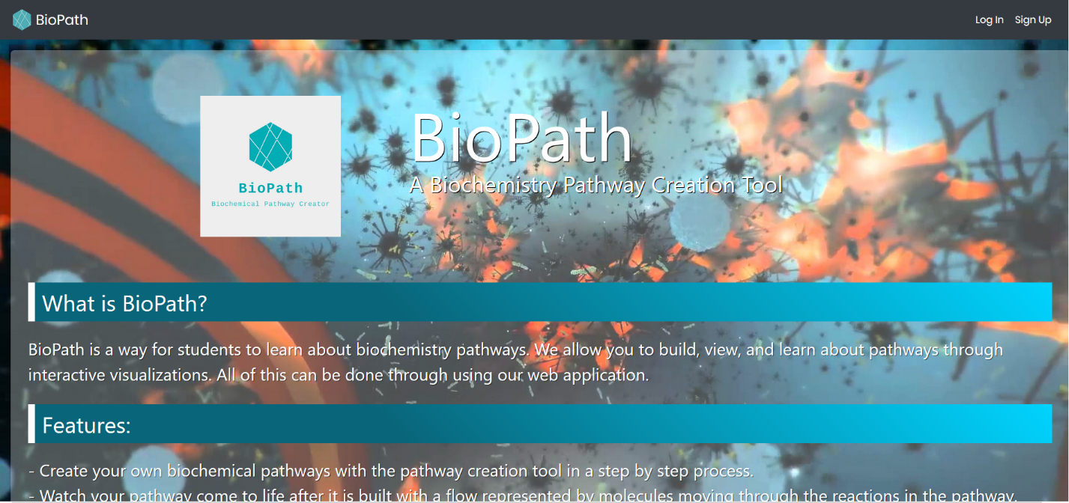

There are three buttons on this page on the top navbar.  reloads this home page. Log In and Sign Up are pretty self explanatory

## SIGN UP

You need at least input for username, email, password, and password confirmation. If you would like to sign on with your google account, you can check out the information here.

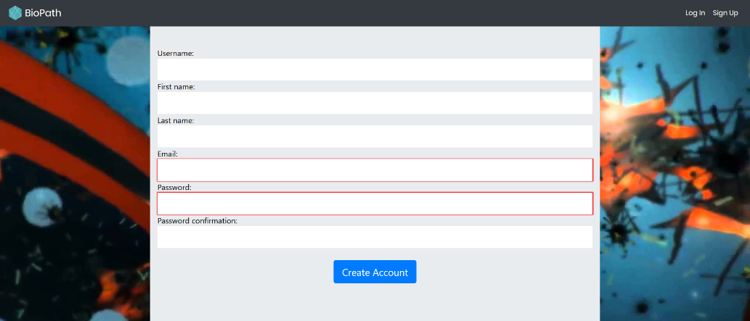

## LOG IN

The only place you can change your password currently is here, where you click Forgot Password.

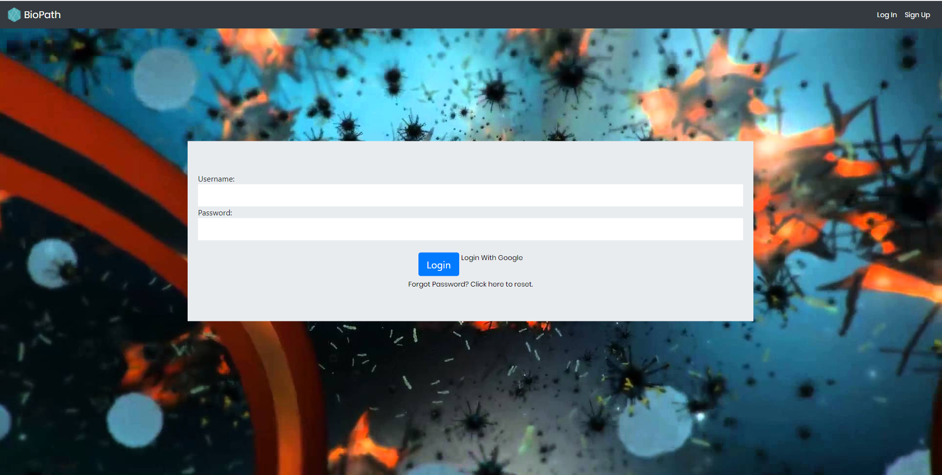

Upon putting in a legitimate Username and Password combination and clicking ‘Login’, you will be taken to the modelChoice page

Or

You can chose to login with your google account

## modelChoice

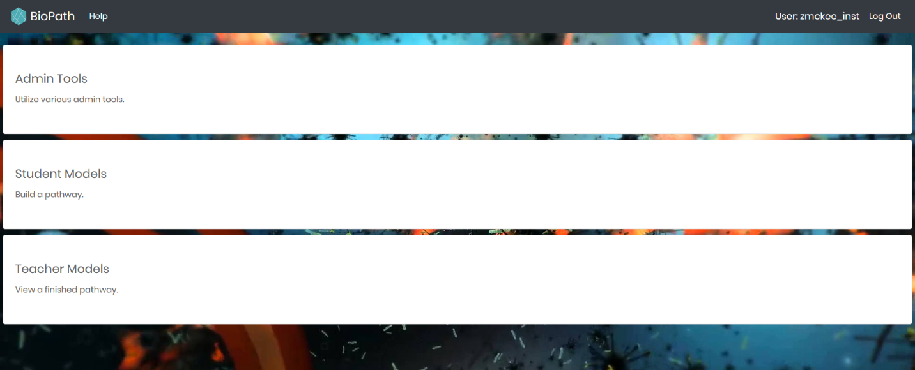

A number of things to talk about here.

For the TopNav bar:

1. Clicking 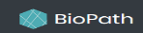 from here or any other place on the rest of the website will reload this page.
2. The Help button contains helpful text about the page a user is on
3. Log Out button logs you out.

The other 4 (or 3) buttons.

1. Admin Tools: this button will only appear if the user is a qualified admin
2. Student Models: (2018-2019 this was called Your Models. We changed the name.) This page brings the user to models that they can work on to complete
3. Teacher Models: (2018-2019 this was called Our Models. We changed the name.) This page brings the user to finished models/pathways. Here they can see what they should be building
4. Getting Started: A helpful video that exists to make using the website easier with a more gentle learning curve.

Note: Throughout the code and documentation we sometimes use the words pathway and model interchangeably. In many cases model refers to pathway. However, Django and Python have computer science objects named Models as well. You will need to know the context to know which model means what.

## Admin Tools

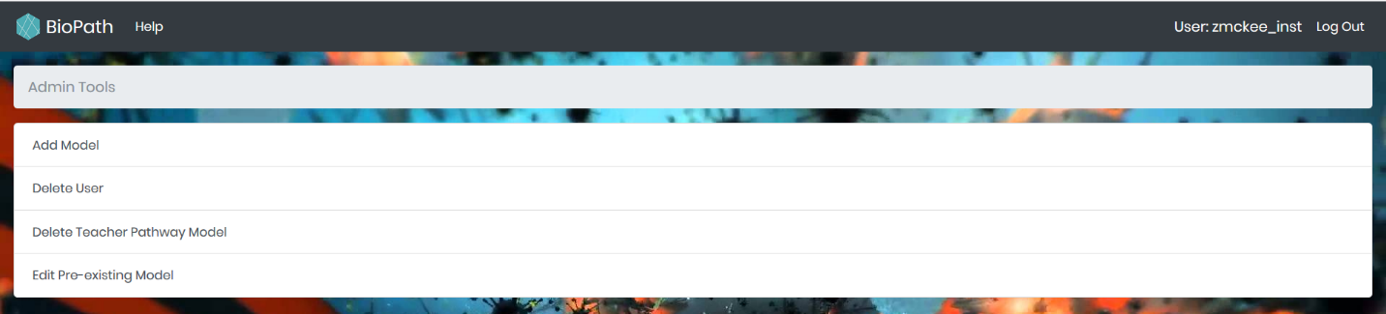

There are currently 4 options on this page for admins.

1. Add Model: This is the UI for the admin to add a new public model/pathway to the database for all users to see
2. Delete User: UI for an admin to delete users
3. Delete Teacher Pathway Model: If an admin wants to remove a pathway from the database. Very helpful for testing when we want to delete useless pathways
4. Edit Pre-existing Model: If an admin were to make a mistake on a pathway and wants to fix it

### Admin Tools: Add Model

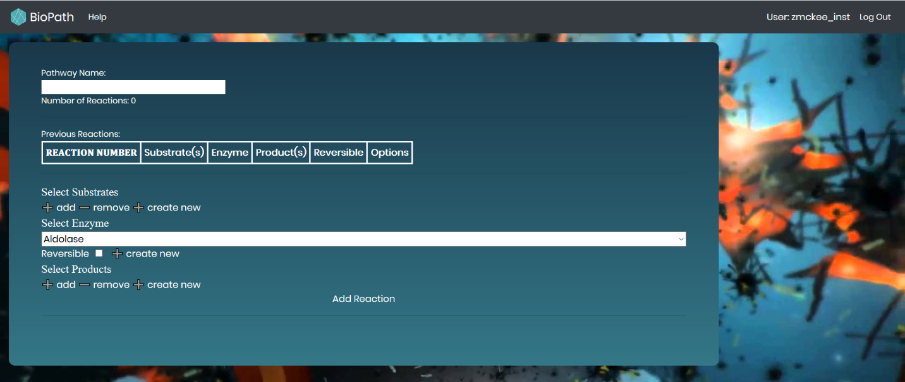

* The ‘Pathway Name’ box allows the user to select the name of the pathway they wish to add.
* The ‘Previous Reactions’ section is a table that is expanded every time the user adds a new reaction to their pathway.
* In the ‘Select substrates’ section, the user has three buttons.
  + The first button, ‘add’, creates an HTML select element so that the user can select what the first substrate in this reaction is. The user can choose up to 5 (hardcoded number) select boxes for adding up to 5 substrates to the reaction. The select elements are populated with every substrate currently in the testApp_substrates table.
  + The ‘remove’ button will remove an HTML select element in case the user added too many substrates.
  + The ‘create new’ button will open up a new Modal box allowing the user to create a custom substrate that does not currently exist in the database
* The ‘Select Products’ section is the same as the previously mentioned section, except it shows a list of each product currently in the database.
* Similarly, the ‘Select Enzyme’ section has a single select box which stores all the enzymes currently in the database. This box cannot be removed, nor can any more enzymes be added to a single reaction, as each reaction only has one enzyme.
  + This section contains a ‘Reversible’ checkbox that signifies whether this reaction can go both ways or if it can only convert substrates to products.
  + It also has a ‘create new’ button that functions exactly like the one for substrates and products
* At the bottom, there is an ‘Add Reaction’ button, which will perform some error checking and then if the reaction is valid will add it to the list of added reactions.

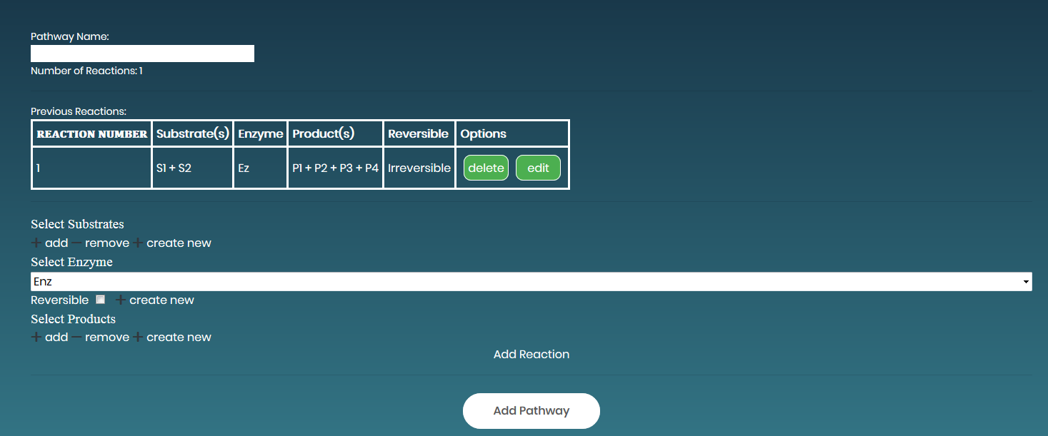

* Once a reaction is added, it shows up in the ‘Previous Reactions’ table, where it has two buttons. ‘delete’ will delete the reaction and shift all reactions below it up by one, and ‘edit’ will bring up the ability to change the substrates, enzyme, and products in a specific reaction.
* After adding one reaction, an ‘Add Pathway’ button will appear, which will perform some error checking and if the pathway is valid add it to the database.

Before a user can add the pathway to the database they must:

* 1. Have admin/superuser status on the website
  2. Add at least one valid reaction (press add reaction text to do this)
  3. Name the pathway. Pathway name must not already be in the database. Must be unique.
  4. Click the Add Pathway button

What it looks like with some reactions:

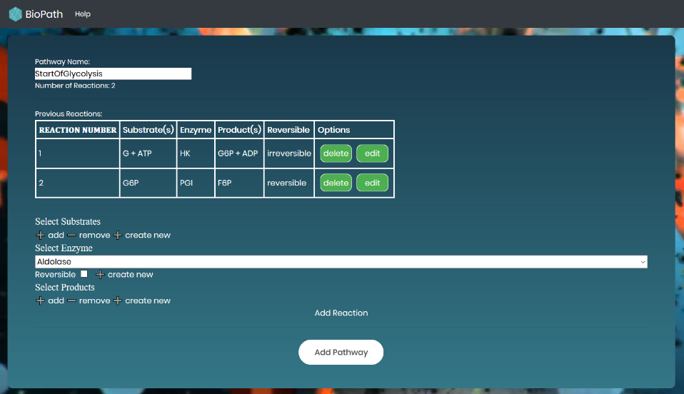

Error Checking

Our system enforces some constraints that were given to us by Dr. Watson and also recommended by our advisor Prof. Bryant. The javascript that works on this page is addModel.js.

* + No two pathways can have the same name
  + No two substrates, enzymes, or products can have the same name
  + Each reaction must have at least one substrate and at least one product
  + No reaction can have two of the same substrate or two of the same product
  + No two reactions in a pathway can have the same enzyme
  + Each reaction, minus the first reaction, must have at least one of its substrates as the product of the previous reaction.

Another thing our error checking does is to alert the user if there are any products or substrates that in any reaction that do not come immediately from the previous reaction. This is not something that is disallowed, as pathways use free-floating substrates and release products into the cell that are not used further along in the pathway. Our system produces javascript confirm boxes when the user decides to add the final pathway just in case they did not mean for these reagents to be free-floating.

### Admin Tools: Delete User

Upon selecting at least one user and the “delete user” button an alert box appears double checking with the user.

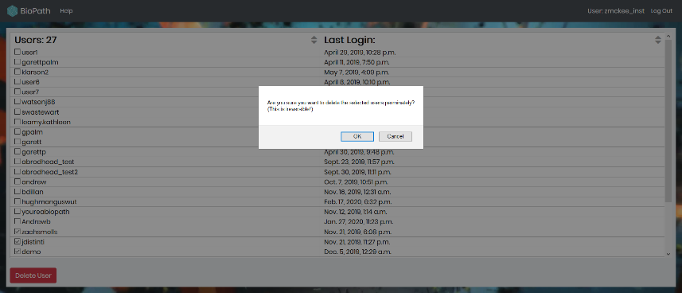

### Admin Tools: Delete Teacher Model

Upon selecting at least one pathway and the “delete models” button an alert box appears double checking this is an action the user wishes to take.

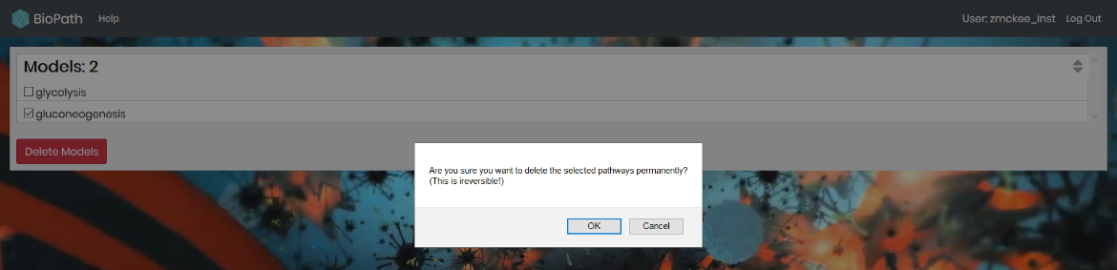

### Admin Tools: Edit Pre-existing Model

Upon selecting one pathway and clicking the “Edit Model” button the admin will be redirected to the Add Model page with all of the info for that pathway filled out.

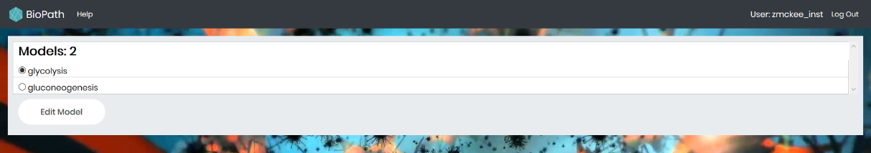

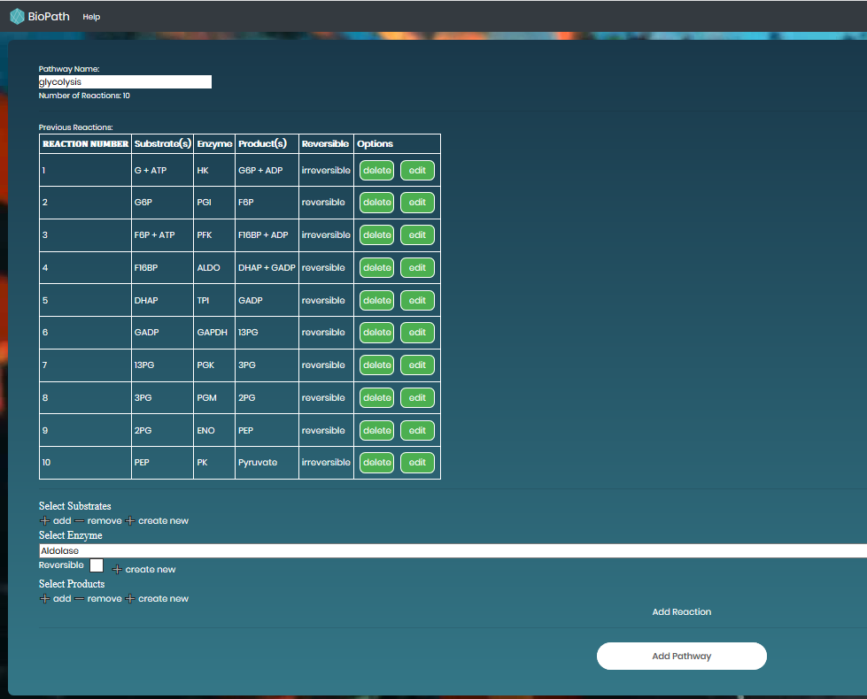

Now if you edit something the old version of glycolysis gets replaced with the new version. Our application currently deletes the old model from the pathway once they hit the button with a valid pathway, and adds the new one in. It performs the same error checking, but with the exception of allowing the user to keep the same name of the old pathway. Note: All users will lose all of their work on the old model.

## Student Models

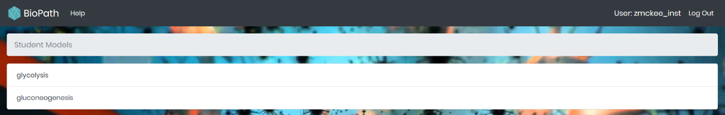

Upon clicking one of the models you will get redirected to the editModel page

### Student Models: Edit Model

If this is your first time working on a model you will see the following:

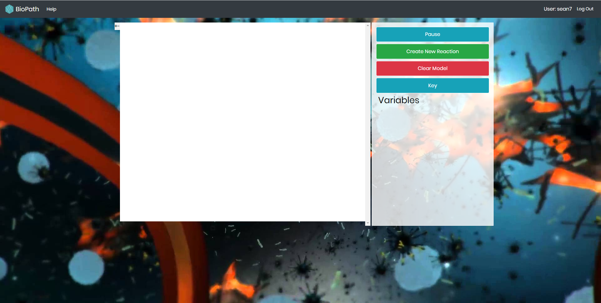

Otherwise you might see something similar to the following:

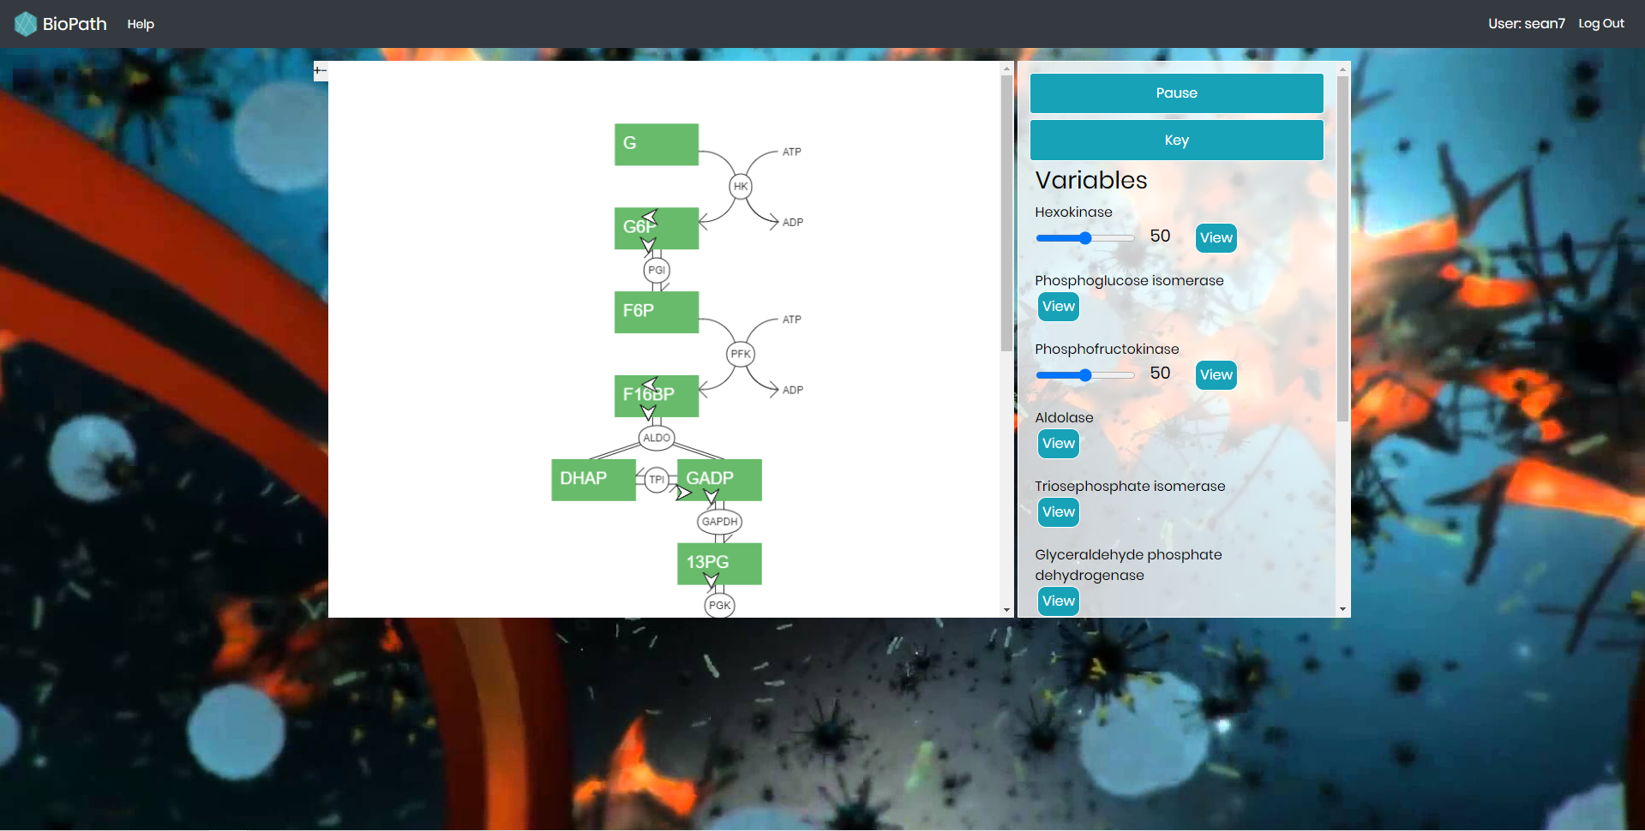

The sliders to the right for Hexikonase and Phosphofructokinase are always present for irreversible reactions. The make the animation for the blue circles going through their reaction speed up. Clicking edit will take you to the Create New Reaction page, but you will not have the ability to add a new reaction, just view them.

Pause Button

Pauses the animation. Upon clicking becomes the Play button. To pause/play the user can also click or tap the canvas with the model.

Create New Reaction

In order to add the next reaction in the pathway click this button. It will take you to the Create New Reaction page.

Clear Model

If the user wants to start building the pathway anew.

Key

Displays some information that may not be clear without further explanation. Such as what color means what on the display.

#### Student Models: Edit Model: Create New Reaction

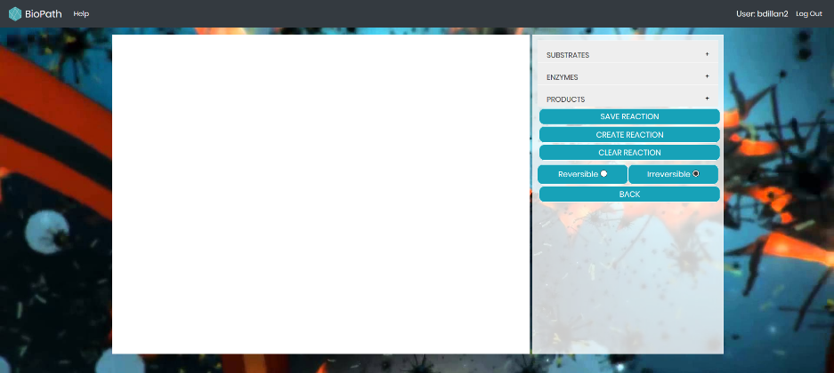

There is a dropdown menu for substrates/enzymes/products. The user can only select one enzyme, but can select multiple substrates and products.

After selecting an enzyme and 0 substrates and 0 products the program will fill in the rest for the user. Since there is never more than one enzyme in a pathway this ability is supposed to be helpful for the user.

The user can select no more than 5 substrates and no more than 5 products.

Upon selecting some combination of substrates/enzyme/products the user should click reversible or irreversible and then click Create Reaction.

1. The Reaction the user has created is the next one in the pathway:

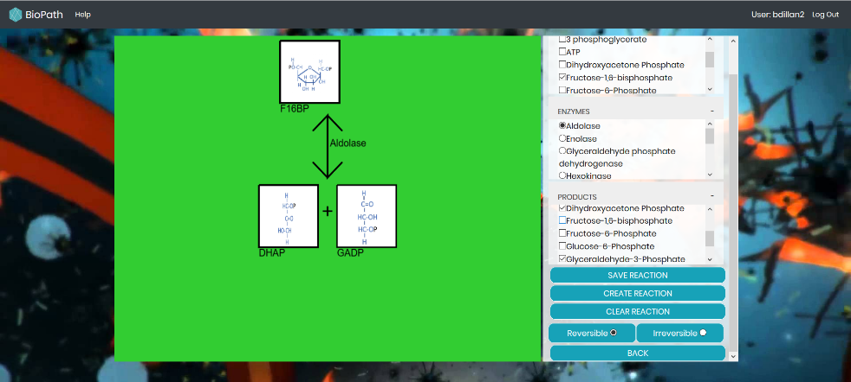

The user will see a green background

1. The Reaction the user created is not the next one but is in the pathway somewhere (might have already been added)

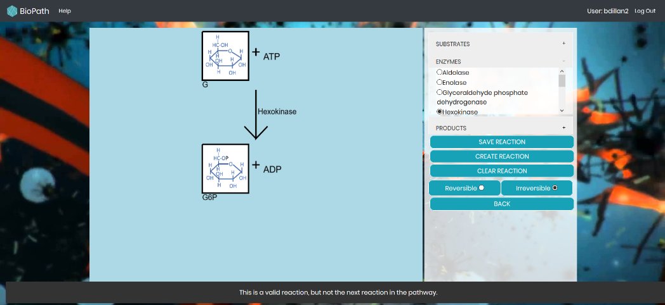

The user will see a blue background and text at the bottom saying “This is a valid reaction, but not the next reaction in the pathway”

1. The Reaction the user created is not in the pathway:

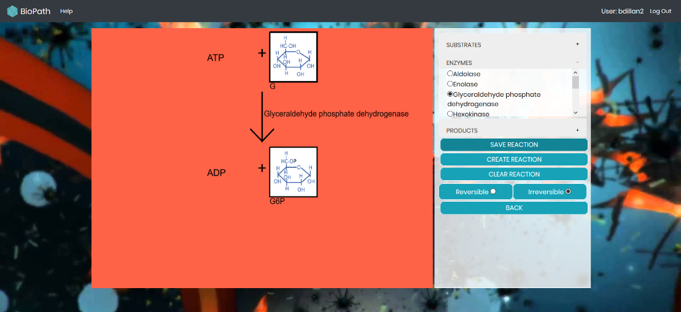

The user will see a red background.

Note: If the user does something that should not happen they might see an error message like the one below popup

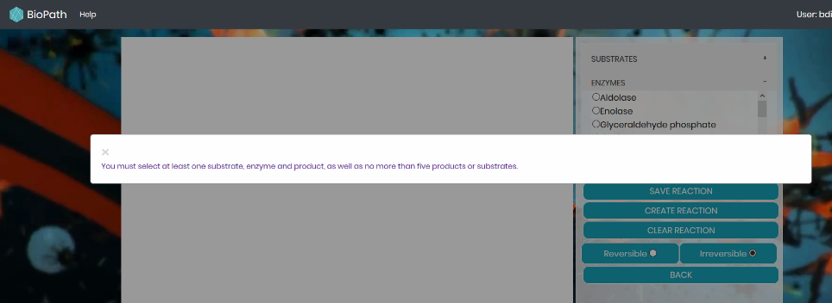

After creating a reaction that IS the next one in the pathway the user must click “Save Reaction” in order to add it to their pathway.

If a user clicks Create Reaction and then changes the enzyme they should click Clear Reaction before clicking Create Reaction. The substrates and products stay the same unless the user unselects them.

The Back button brings the user back to the Edit Model page.

## Teacher Models

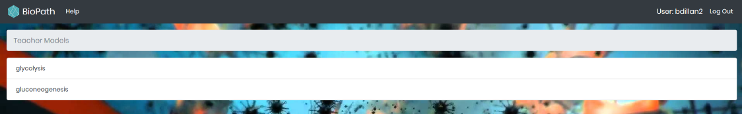

Upon selecting an enzyme the user will be taken to a finished Model Edit page.

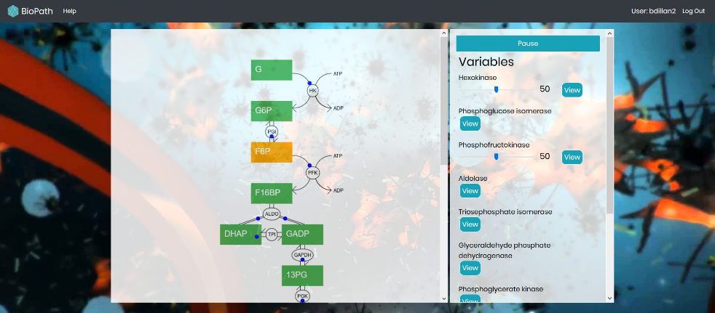

Scrolling is enabled for pathways that are longer than the canvas.

# All about Software

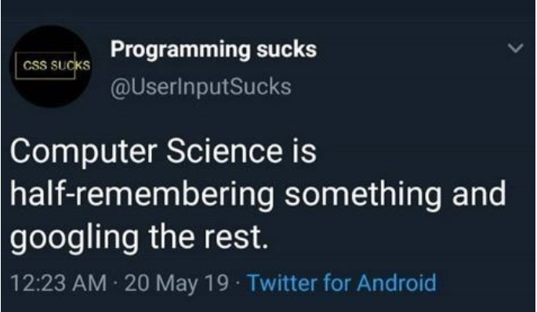

## **Required Software**

Python3, Pip3, Git, MySQL, Django, WSL or bash (Windows only users), allAuth

## **Application Made With**

Python3, JavaScript, CSS, HTML, Django Web Framework, P5JS, NGINX, uWSGI

## **Recommended Software**

* [VisualStudioCode](https://visualstudio.microsoft.com/downloads/) (This is the IDE 2019-2020 Developers Used)
* [Anaconda](https://www.anaconda.com/products/individual) or [Miniconda](https://docs.conda.io/en/latest/miniconda.html) or [virtualenv](https://virtualenv.pypa.io/en/latest/) (basically use some environment manager)

If you haven't already, consider installing an environment manager for Python. It's helpful because it isolates Python dependencies so your computer system isn't being overflowed with them.

When developing, every member used some environment manager so it's highly recommended you do the same.

## **Visual Studio Code**

Visual Studio Code is the IDE that Andrew Broadhead and Ben Bladow used for Software Development. It is nice because it can display a terminal while you work on code.

1. Go to this [website](https://visualstudio.microsoft.com/downloads/) and download the proper version of vs code for your computer.

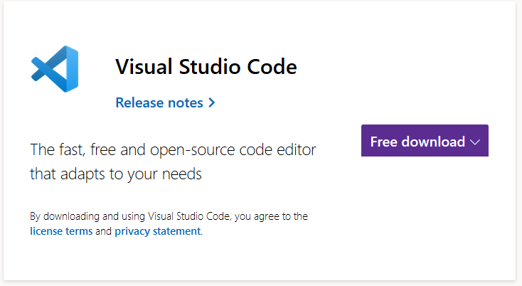

1. Under Select Additional Tasks for the installer make sure you select Add to Path

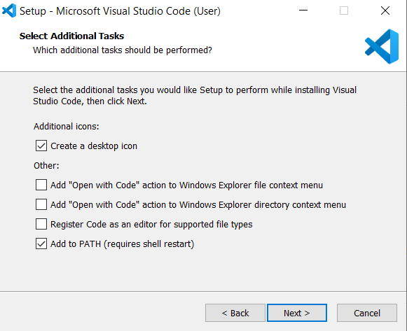

Now, you can decide on whether or not you want to run code off of the server or off of your computer. If you run off the server you anyone on GU’s wifi will be able to access the app. Otherwise it will just be your computer that can access the web app when you run it.

1. Open VS Code and click Add Workspace folder…

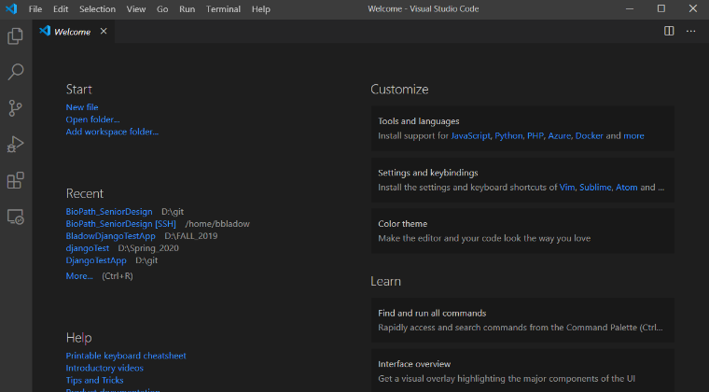

1. Navigate to the folder where you have the github repository stored on your local machine for this project. Click Add.

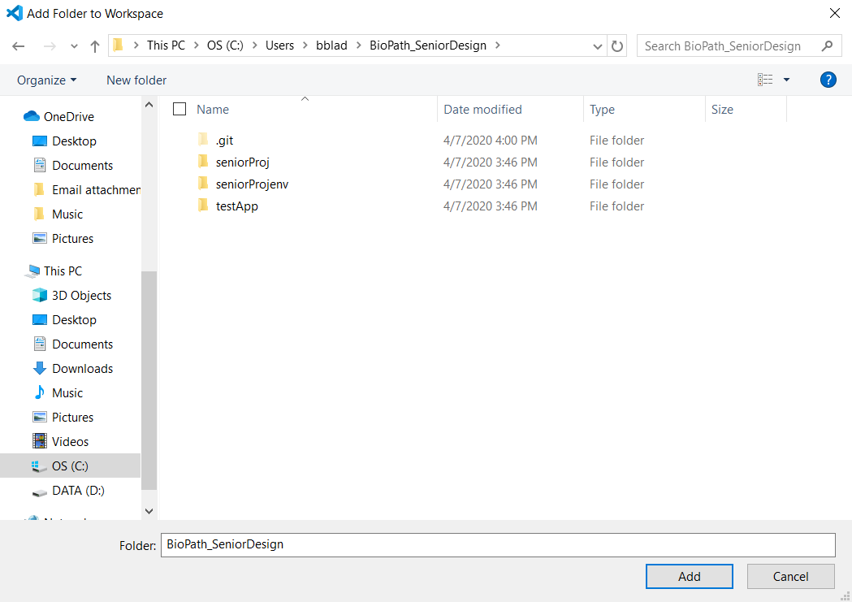

1. Now, open up the terminal. NOTE: You don’t need to do this if:
   1. You are using anaconda/miniconda to run the environment and access the website locally.
   2. And you would prefer to have your own local copy of the code and not store it on the server.
   3. If either the above are the case skip the rest of this VS Code guide.

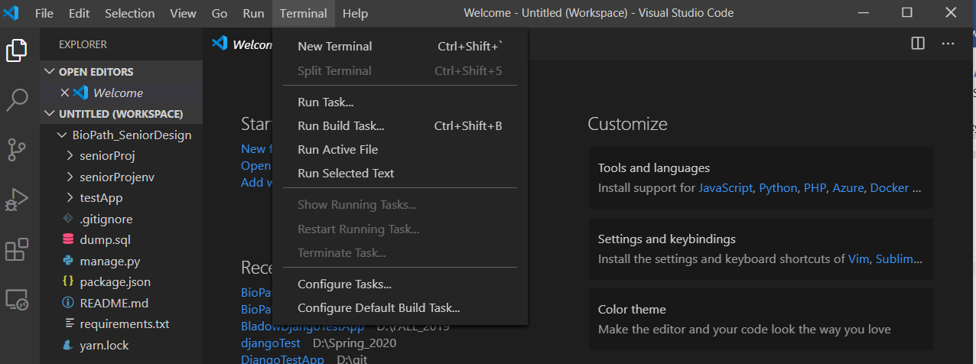

1. I do not know if wsl (windows subsystem for linux) is automatically installed for all VS Code I had downloaded it before downloading VS Code. If not, I suggest installing it because running the code in the wsl terminal is faster for me than using conda.
2. ssh into ada and then ssh into the server (igt4-biochem.gonzaga.edu) NOTE: You will probably need to speak to Jason to get the server back up and running.

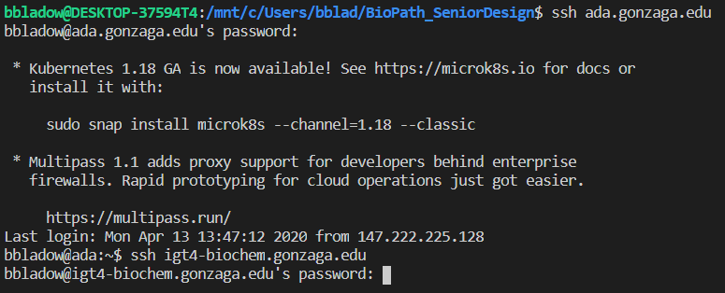

* 1. In order to skip this step every time you open vs code read and follow the guide labeled “Remote Double SSH Guide for VSC”

1. git pull the code if this is your first time working on the server. Then cd into the folder.

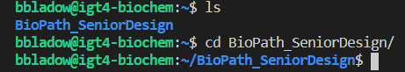

1. Run the following commands
   1. source seniorProjenv/bin/activate [enter]

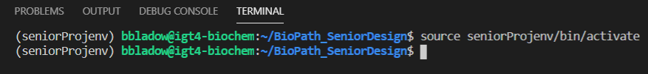

* 1. python3 manage.py runserver 0.0.0.0:8080
     1. You will need to have python3 and probably pip3 installed too before you can run this command
     2. If you are having big unsolvable issues trying to run the server or install python3 and pip3 you can always run the server from miniconda.
     3. 8080 is the port we asked Jason to allow us to run our app on.

1. Now go to your favorite web browser and type: http://igt4-biochem.gonzaga.edu:8080 [enter]

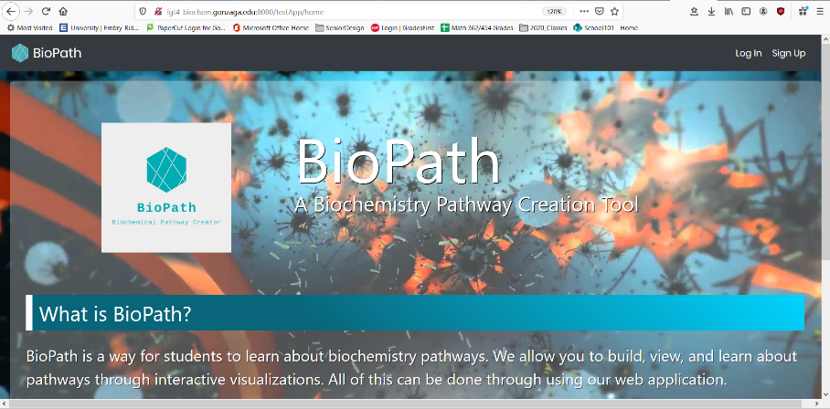

1. You should get output in your terminal.



## **Django Crashcourse**

### What is Django?

Django is a web application framework written in Python. The main goal of the Django framework is to allow developers to focus on components of the application that are new instead of spending time on already developed components. Django includes things you can use to handle common Web development tasks such as authentication, content administration, site maps, and RSS feeds.

### Key Django Concepts

* 1. Project: A web application using Django. It is a collection of configuration and apps for a particular website. Basically, it is the website itself. A project can contain multiple apps.
  2. App: Generally, apps are what make up a project. It is a submodule of a web application that is designated a duty – e.g., a Weblog system, a database of public records or a simple poll app. In theory, you could take an app and place it in an entirely different project and it would still work.
  3. View: A “type” of Web page in your Django application that generally serves a specific function and has a specific template. Basically, it defines what is going to be displayed on a web page like the HTML contents. Views in Django have to be created in an app's views.py file.
  4. Model: It contains the essential fields and behaviors of the data you're storing. Generally, each model maps to a single database table. Another way to think about this is that Django converts your model into a SQL table. Maybe you want to store information about what year your family members were born. You specify in the model what attributes/things should be stored in the SQL table you want to make. In this case, one variable would be the name of the family member and the another variable would be the date they were born. Django will automatically create a SQL table for this. This may [help](https://docs.djangoproject.com/en/3.2/topics/db/models/).
  5. Migration: This is Django’s way of storing changes you make to your models (adding a field, deleting a model, etc.) into your database schema. This may [help](https://docs.djangoproject.com/en/3.2/topics/migrations/).
  6. Template: Django needs a convenient way to generate HTML dynamically. A template contains the static parts of the desired HTML output as well as some special syntax describing how dynamic content will be inserted.

A friendly [useful resource](https://docs.djangoproject.com/en/3.2/) for you to use at your whim.

### Basic Commands

Important and frequently used arguments in Django.

python3 manage.py runserver  
Starts development server on the internal IP at port 8000.

python3 manage.py runserver 8080  
A different port can be specified by adding it at the end of the argument. This example sets the port to 8080.

python3 manage.py makemigrations   
Tells Django that you’ve made some changes to your models and that you’d like the changes to be stored as a migration.

python3 manage.py migrate   
Runs the migrations for you and manage your database schema automatically. This command takes all the migrations that haven’t been applied and runs them against your database - essentially, synchronizing the changes you made to your models with the schema in the database.

python3 manage.py createsuperuser  
Creates a user who can login to the admin site. This will prompt you to enter in a username, email address, and a password.

python3 manage.py startapp [app_name]  
Creates a directory with several files for the app with your given app name.

python3 manage.py test [app]  
Run automated tests to test Django code.

### Testing in Django

Django has ways to create automated tests for your Django code. If you aren't familiar with testing, creating code to test the application is a great way to identify and prevent problems.

[This](https://docs.djangoproject.com/en/3.2/intro/tutorial01/) Django tutorial covers the basics on how to test each part that makes up the application.

### User Permissions

Assigning permissions is relatively straightforward code wise. It is generally one line of code. There are two ways that we use permissions in our application. We use permissions to restrict certain users from accessing a HTML webpage or hide content from unauthorized users.

#### Where are permissions assigned in our application?

There are two places where we primarily use permissions. The first one is in views.py. In here, we assign @login_required(login_url='/accounts/login/') above any function that returns an HTML page so it will only allow logged in users to access those pages. Functions that use this requirement are: modelChoice(), moduleEdit(), modelEdit(), studentModels(), and teacherModels().

Another permission that we assign in views.py is @permission_required('catalog.add_model'). We treat this as a permission that allows only administrators to access the page. Functions that use this requirement are: edit_model(), add_model(), adminEditModel(), adminDeleteUser(), and adminTools().

All the permission arguments in views.py restrict who can view the webpage.

The next place where user permissions are decided is in modelChoice.html. In here, we hide certain HTML content from unauthorized users. An example of this is:

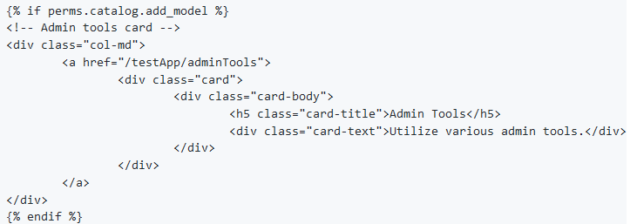

The code {% if perms.catalog.add_model %} is an if-statement using Django's template language that checks to see if a user is an admin. If they are an admin, they can view the content until the end of the block {% endif %}. If the person is a regular user, this content won't appear to them.

#### Distinguishing admins from other users

Currently, the way we separate admins from regular permissions is with the add_model permission. We would have liked to implement a role based system where each role gets a certain set of permissions so instead of add_model, we could use admin.

#### Finding the list of permissions

The list of permissions can be found by going to Django's admin page. Go to http://127.0.0.1:8001/admin/ and go to Group. Then click the Admin group and see all the permissions. Note that none of the permissions actually restrict anything yet. Most of the permissions aren't even needed (It was added by the first group not me ok).

## **CSS and Bootstrap**

### Bootstrap Implementation

We implemented Bootstrap into our application to suppport multiple screen sizes including mobile devices.

#### What is Bootstrap?

Bootstrap is basically a library of CSS styling sheets with bonus functionality using JS/JQuery. A more in-depth explanation can be found on their [site](https://getbootstrap.com/docs/5.0/getting-started/introduction/).

#### How is it implemented into our application?

We downloaded the Bootstrap files from the official Bootstrap website. The Bootstrap files in the BioPath application can be found in \testApp\static\vendor\bootstrap. In particular, the file we used was bootstrap.min.css. To be honest, you could probably get rid of the rest of the CSS files in that folder as they are just different forms of Bootstrap depending on your needs.

#### Why use bootstrap.min.css instead of bootstrap.css?

Both of these files contain the same information, but the difference is that the min version has no whitespace, therefore reducing file size. The bootstrap.css file is easier to read, but is much larger. Whenever I'm making changes to the Bootstrap files, I do read bootstrap.css to find the info I want, but load bootstrap.min.css into our application. In this case, it might be helpful to still have the bootstrap.css file.

#### Modifications made to the Bootstrap files

There are some things we modified from the bootstrap.css file. However, these changes were made in \testApp\static\css\bootstrap-override.css. We did it this way instead of modifying the bootstrap.min.css file because if something went wrong with our Bootstrap elements, we could easily revert back to the default elements by deleting bootstrap-override.css. Our changes made were relatively minor, with most of them having to do with element colors or element size.

#### Where are the Bootstrap files loaded in the application?

There are two places where we load the Bootstrap files. The first one is in index.html and the other is in indexLogged.html. The CSS files are loaded at the top of the HTML files. Because the CSS files are loaded in index.html and indexLogged.html, their CSS properties will also apply to the HTML files connected to them.

#### How are the Bootstrap elements called in the application?

The Bootstrap elements are called like a normal CSS class or id. It's just a matter of knowing which element to call. A comprehensive guide of all the Bootstrap elements that can be used are found in the resources linked below.

#### Useful Bootstrap Resources:

[Official Bootstrap Documentation](https://getbootstrap.com/docs/5.0/getting-started/introduction/)

## **Various Guides**

This section was created with the purpose of storing documentation as we continue through the development of the BioPath web application. It contains a bunch of random things we learned during our process of our development of this web application that could be useful.

### Python Web Dev

• [Python Web Development](https://realpython.com/tutorials/web-dev/)

* Super helpful guide if you are completely new to web development or Python. Even if you have experience, it has a lot of useful information that might give you some good ideas.

### Remote Double SSH Guide for VSC

TODO: Copy/Paste from the github

• [Remote Double SSH Guide for VSC](https://code.visualstudio.com/blogs/2019/10/03/remote-ssh-tips-and-tricks)

* This is a guide to setting up the Remote SSH Extension for VSC to double SSH so you can still use VSC when editing files on the server.

# The DATABASE (bum bum bumm)

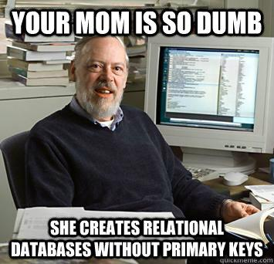

## **Installing MySQL**

### Installing for Macs

* Download MySQL [here](https://www.mysql.com/downloads/).
* Once installed, go to the terminal and enter the following commands (this is for bash):

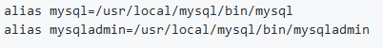

* You now should be able to use mysql and mysqladmin commands.

### Installing for Linux or WSL

* + - 1. Install via Bash/WSL

Type: 

You might need to type:  if the above command fails

* + - 1. Once you have finished installing, Type: 
      2. Run the mysql instance with: 
      3. If that does not work: 
      4. Once in mysql, you can see the databases with: 
      5. Exit mysql with: 

### Resources

Info for the WSL installation was taken from this [guide](https://docs.microsoft.com/en-us/windows/wsl/install-win10) and from Stack Overflow for errors.

## **MySQL Workbench**

1. Install [MySQL Workbench](https://dev.mysql.com/downloads/workbench/)
2. Click the plus button to add a connection:

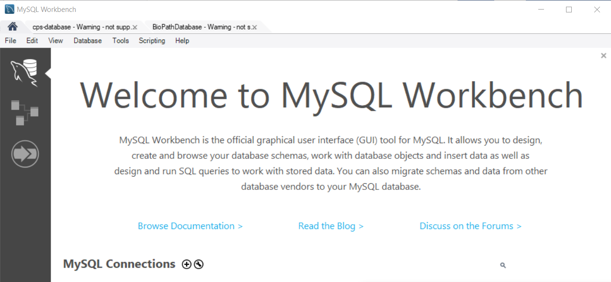

1. Name the Connection whatever you wish and select Standard TCP/IP over SSH

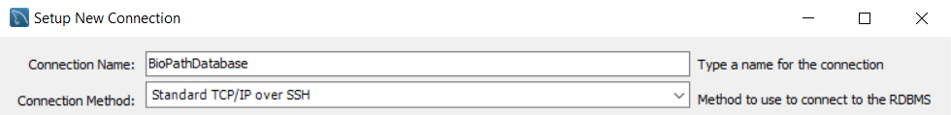

1. Fill in the following information. Make sure to add your passwords for ada and the cssd07 by clicking “Store in Vault”

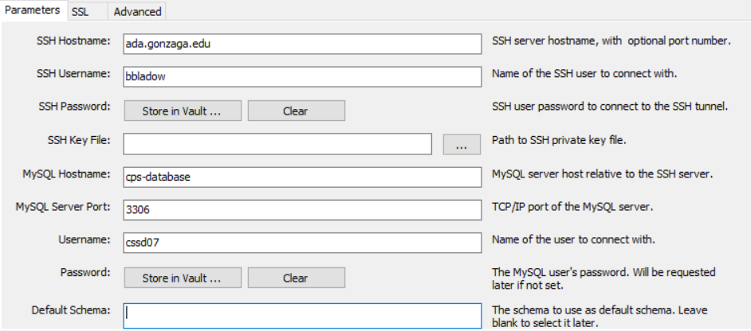

1. To make sure the connection is good, click “Test Connection”. If everything is good click “OK”.

## **Accessing the Database**

### Overview

We are using gonzaga's cps-database in Paccar for hosting the database that our web server is linked to. For development, you can use this one or create a local one on your machine by following the instructions at 5A and load in a dump file.

### Database Credentials

Hostname: cps-database   
Username: cssd07 (Dr. Watson has own username and password)   
Password: B10Te@m!   
Note: Everything else should be blank

There are three ways to add data into the database. The first way utilizes mysql workbench (which we consider to be easier) or inserting data using your computer's terminal/console. The third way is using running the app and using the UI to add things to the database.

### Instructions for MySQL Workbench

Go to Query (Lightning bolt)

Select a table → EX: select * from testApp_model (should be written in query)

Export data button above table

Delete the file → EX: delete from testApp_mode (also written in query)   
a. Note: make sure data is exported correctly before deleting.

Select the changed csv file and import it into the same table as before. Ex: select * from testApp_model

Right click on table and and select import wizard

### Instructions for Terminal

* + - 1. Edit tables on excel
      2. Save tables into senior design folder
      3. Get onto bioChemApp_SeniorDesign file on terminal (will share folder)
      4. On Terminal
         1. To Change directory in Senior Design folder   
            cd CSVfiles
         2. To move file to ada:   
            scp testApp_model.csv account@ada.gonzaga.edu:testApp_model.csv
         3. To get into ada   
            ssh account@ada.gonzaga.edu
         4. To view what is in the directory and make sure the file moved over   
            Ls
         5. mysql -u cssd07 -p -h cps-database
         6. To get into the database:   
            password: B10Te@m!
         7. To select the right database   
            USE biochemDB
         8. Delete table before so it is empty when the new data is added   
            Delete from modelName;
         9. Select * from modelName; (to make sure table is empty)
         10. LOAD DATA LOCAL INFILE “file” INTO TABLE model FIELDS TERMINATED BY ‘,’ LINES TERMINATED BY ‘\n’;

To load data from csv file into table OR source script.sql (to save time) (I will add in the script query on your terminal)

To select a specific table: select * from table to make sure data is added correctly.

## **Create a new Linear Pathway (without branches or cycles)**

This all comes from my playing around and tests building one myself. If you are in MySQL workbench these are the tables and the order in which you need to modify them in order to write a new pathway to the database.

1. Create a new pathway in the testapp_model table

* The required fields are as followed:
  + Id: leave this null and let it auto generate
    - NOTE: Get this id back somehow as it is necessary when adding the enzymes, substrates, and products.
  + modelName: The name for the pathway
  + userId_id: Set this to whatever user is creating the pathway or 2? (I don’t think this matters all that much)
  + Public: Set to 1 to make the pathway public. The app auto generates new entries in this table when a user tries to create their own pathway (I need to verify this for sure, but that’s what’s happened so far), so you shouldn’t need to make a non-public pathway manually

2. Create the enzymes in the testapp_module table

* The required fields are as follows:
  + Id: leave this null and it will auto generate
    - NOTE: Get this id back somehow as it is necessary when adding substrates and products
  + modelID_id: This is the id of the pathway (model) that this enzyme belongs to.
  + Enzyme: This is the name of the enzyme
  + Reversible: Set this to “reversible” if you want the reaction to be reversible, “irreversible” otherwise.
    - NOTE: We should really change this to be 0 or 1
  + enzymeAbbr: This is the abbreviation for the enzyme that is displayed when the model is shown
  + xCoor: This should be 0 if the pathway does not branch. Change this to shift where the enzyme draws from the left to the right.
  + yCoor: This is the position that the enzyme is drawn vertically, starting at 1.
    - NOTE: For splitting paths, you need to set two different enzymes to the same yCoor or something? Still figuring out how this all works for those
  + enzWeight: Set to 1, all the other ones are 1, haven’t tested changing it around yet
  + deltaG: Honestly not really sure, doesn’t seem to make a difference what these numbers are.
  + deltaGNaughtPrime: Same as the above one lol, we need to ask Jeff what these mean

3. Add the substrates and products to the testapp_substrate and testapp_product tables.

1. NOTE: These tables are essentially the same, the only real difference that the column for the name is changed from product to substrate
2. NOTE: You need to add a reactant to both the product and substrate if it is used from one reaction to another
3. The required fields are as follows:
   * Id: Leave this null and it will auto generate
   * product/substrate: This column is for the name
   * moduleID_id: This is the ID of the module the product or substrate belongs to (the enzyme)
     + For a reactant that goes from one enzyme to another, there should be an entry in the products table with the earlier enzyme in the moduleID_id column and an entry in the substrates table with the later enzyme in the moduleID_id
   * Abbr: The reactant abbreviation
   * modelID: This is the id of the model (pathway) the reactant belongs to.

## **Creating or Restoring a Backup**

For myself, running bash/WSL on a Windows 10, I had to put sudo in front of all or most of the following commands.

### Creating a backup of the database

* To create a backup, ssh into ada and run the following command:   
  mysqldump -u cssd07 -p -h cps-database biochemDB>dump.sql
* It will prompt you for a password and replicate the entire database into dump.sql.
* Change the filename if you want.

### Restoring the database from a backup

* Access the database using the terminal (see database instructions doc)
* To swap to the correct database, type:   
  use biochemDB;
* Make sure you are in the same directory as your backup sql file on ada and type:   
  source dump.sql;
* Replace dump.sql to whatever you named your backup

### Copying the database locally

This basically combines creating and restoring backup steps, but we’ll go through it anyway.

1. First, we want to create a backup. To create a backup ssh into ada and run the following command:
   1. 
   2. It will prompt you for the database password; B10Te@m!
   3. Copy the dump.sql from ada onto your local machine
   4. Exit out of ada, but stay in the terminal
   5. Change the filename of the dump.sql file if you wish
2. In the same directory on your local machine where the dump.sql file is stored run the following command
   1. 
   2. [username] is the username you have created for mysql on your local machine (if you have not created a username for mysql, then this will be root. It is good practice to create your own username)
   3. [hostname] is most likely going to be localhost
   4. *IF* you get the following error when trying to run the command in 2a:



* + 1. Run this command before trying 2a again:

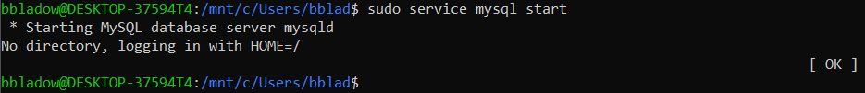

1. Now create a new database: 
2. To now be able to write/read the database run: 
3. Make sure you are in the same directory as your backup sql file and run: 
4. Type exit; [enter] to exit mysql
5. Then in settings.py you’ll need to modify the DATABASES dictionary:

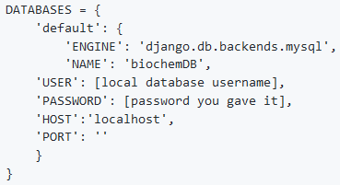

## **Write to the Database Backend with Django**

Django creates python instances of each table in the database which it calls Models. These objects are created in Models.py as individual classes that inherit from ‘models.Model’ and represent a row in a database table, and each class contains attributes that correspond to a row in that table. Models can be accessed in views.py. At the top of the program, there are import statements for each Model, e.g. ‘from testApp.models import Substrates’. The models can then be queried using the method calls such as “Substrates.objects.all()” to get a list of all objects in the testApp_substrates table. These object lists also have a ‘filter()’ method for selecting only the desired rows. For example, ‘Module.objects.all().filter(modelID_id = 5)’ would return a list of all rows in the Module table where the modelID attribute is 5. You can also use the get() method instead of filtering the list of all objects for retrieving a single row from a table.

For writing new rows to the tables in the database, we initialize a variable to be the type of the Model we wish to add it to. E.g ‘productToAdd = Products()’ will begin the process of creating a new row in the testApp_products table. Then we fill out each necessary attribute of the row in the format: ‘productToAdd.attribute = value’. When all the attributes are filled in, we use ‘productToAdd.save()’ to add that row to the database. For reference on how we added things to the database, see the method writeModelToDatabase() in views.py lines 471-531.

For deleting database rows, call the delete() function on a query of rows to delete them. For example, in views.py: adminDeleteUser(), lines 550-588, we use ‘User.objects.get(id = userID).delete()’ in order to delete the user from the database whose id corresponds to our variable userID. Django allows for cascading delete, which deletes an entry in the database along with any entries in other tables that have foreign keys corresponding to that entry. For example, deleting a user will also delete all their attempts at pathways in the testApp_models table.

## **Entity-Relation Diagram**

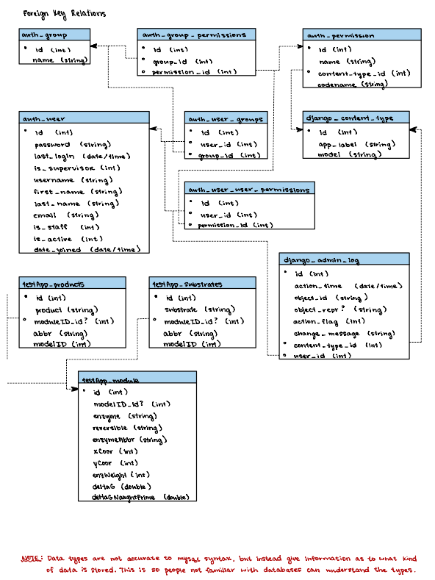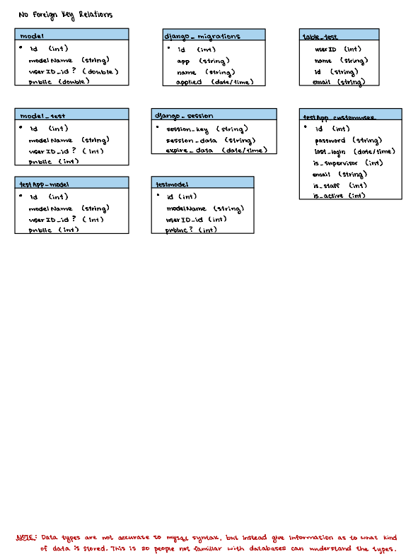

# 6. Overview of the Code

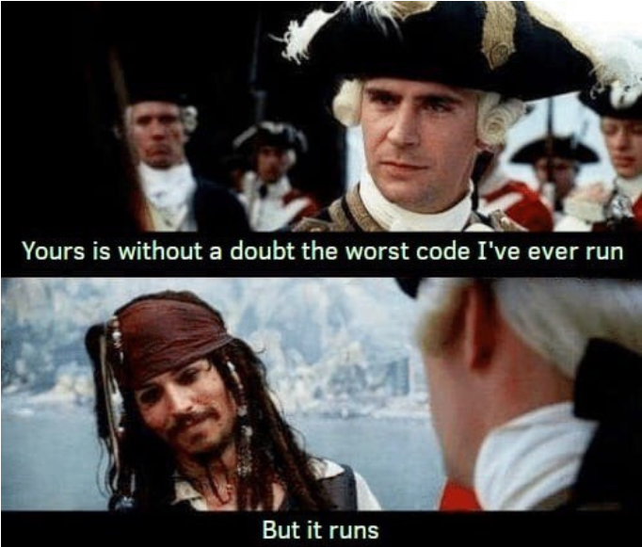

New Developers

Previous Developers

## **Important Frontend Files**

### Django Files

Django generates a lot of files, but there are specific ones to be aware of when modifying this web application.

#### Manage.py

Created by Django when the project is created and is located at the root directory. It is the first file that runs when you run the server. It specifies what version of Django to use and any other connected software.

#### Settings.py

Created by Django and is located inside the seniorProj directory. It contains all the settings for your project and links the project to your database. It also links to SendGrid which allows users to reset their passwords over email. Be sure that Debug is set to false for this file on the production server.

#### Urls.py

A file created by Django. NOTE: There are two urls.py files: one in the seniorProj directory and one in the testApp directory. The one in the testApp directory is what we use for our website. Here you supply all of the url patterns that are recognized and link those urls to a particular view in views.py. You can think of urls.py as a router, it takes in the url from the browser and routes you to the appropriate view. There is one url for each of our webpages.

#### Views.py

A file created by Django. It controls what code runs when a particular webpage is opened. For example when the modelChoice screen is opened the urls.py routes us to the modelChoice function in views.py and that function determines what data to send to the webpage. In Django's models, they are references to specific tables in the database. To continue with our example, modelChoice links to the Model table in the database. ** TODO: NEEDS MORE EXPLANATION **

#### Models.py

A important Django file that is used to create models, which are representations of the database tables. There is one model per database table. In our project we have four primary models: Models, enzyme reactions (Modules), Products and Substrates. For the most part, every column in your database table becomes a variable in your model in models.py.

### JavaScript, HTML, and CSS Files

#### Templates

Inside of the testApp directory there is a templates directory. This directory holds all of the HTML files for the project. These HTML files are called by the views functions. At the bottom of each views function there is a return statement. This return statement, sends a request, calls a specific HTML file and sends the context variable. For example if you look at the return statement in the modelChoice function in views:

return render(request, 'modelChoice.html', context=context)

As you can see the modelChoice function is calling modelChoice.html, which means this HTML file will be rendered. Each HTML file extends indexLogged.html. But other than that, we use standard HTML throughout.

#### Static

Inside the testApp directory there is a static directory. This directory holds all of the JavaScript, CSS, image, and font files. Each JavaScript and CSS file follows the same naming convention as the HTML files. However if it is unclear which JavaScript file goes to each HTML file, there is a line in each HTML file, encapsulated in a script tag, that links the JavaScript file. All of the CSS files are linked in the indexLogged.html file.

### Javascript Files

#### modelEdit.js

THIS IS ONE OF THE MOST IMPORTANT FILES FOR DRAWING PATHWAYS. IT TOOK US A GOOD WHILE TO LEARN. It is so important it gets its own section. PLEASE GO TO SECTION 7 TO LEARN MORE.

#### drawPathway.js

This file will eventually replace modelEdit.js, and uses an OOP approach to drawing both linear and circular pathways. This file makes use of p5.js, which is a Javascript library used for drawing sketches to the screen. For more information on it here is a useful [website](https://p5js.org/). The first function that is run is setup(), which creates the canvas that the pathways are drawn on and puts data from the database into arrays. The next function that is run is draw(), which is intended to be a function that loops. However, currently we have it only running once. This will need to change when the rectangles change color based on “fullness.”

* Enzyme(class): This class contains information concerning enzymes in a pathway.
  + drawEnzyme(): This function calls all the necessary functions in order to draw an enzyme.
  + drawCircle(): This function draws an enzyme circle.
  + drawText(): This function draws the text within an enzyme circle.
  + checkWidth(): This function checks to see if the text at size 15 will fit within the enzyme circle. If not, the text size will be lowered to fit within the circle.
* SubstrateProduct(class): This class contains information concerning both substrates and products in a pathway.
  + drawSubstrateProduct(): This function calls all the necessary functions in order to draw a substrate or product.
  + drawRectangle(): This function draws the rectangle for the substrate or product.
  + drawText(): This function draws the text for the substrate or product.
* Reaction(class): This class creates one reaction within a pathway.
  + getSubstrateIndex(): This getter function returns the index of the reaction.
  + getCoordinates(): This getter function returns the x and y coordinates of the reaction.
  + drawSubstrate(): This function draws a substrate.
  + drawEnzyme(): This function draws an enzyme.
  + linRevHorizontal(): This function draws a reversible reaction between two products.
  + drawProduct(): This function draws a product.
  + drawReaction(): This function is called when a Reaction class object is created, and calls all the necessary functions to draw a reaction in a pathway.
  + circStep(): This function draws both a reversible or irreversible circular reaction.
  + linRevStep(): This function draws a vertical linear reversible reaction.
  + linNonRev(): This function draws a vertical linear irreversible reaction.
  + setAngle(): This setter function sets the angle for use in drawing the next cofactor circle.
  + getAngle(): This getter function returns the angle where the cofactor circle was drawn.
* ReactionArrow(class): This class…
  + linearNonReversibleArrow(): hi
  + linearReversibleArrow(): hi
  + linearHorizontalArrow(): hi
  + addCofactor(): hi
* drawArrow(): This function draws the head of an arrow depending on the orientation (ie. left, right, up, or down).
* addText(): This function is used throughout the code, and draws text to the screen given the name, x and y coordinates, and the size of the text.
* determineCoor(): This function calculates the x and y coordinates around a circle.
* determineXCoor(): This function calculates the x coordinate of a circle given a y coordinate.
* addValues(): This function adds values from the database to various lists depending on which pathway is being drawn.
* findAngle(): This function returns the angle between two points of a circle.

#### Molecule.js

This file contains a Molecule class which drawPathway.js uses to create and manage the molecules moving along the pathway.

* calculateOrientation(nextX, nextY) Uses the molecule’s current x, y and the next x, y to calculate the orientation to draw the triangle at.
* progressMovement() Changes the molecule’s current x and y and checks if it is at the next step in the reaction. If it is, it either deletes it if it is at the end of the pathway or changes it’s next destination.
* draw() Calls progressMovement then draws the triangle
* testPastDest() Tests whether or not the molecule will move past it’s next destination
* atNextLoc() Tests whether or not the molecule is at it’s next destination for the purpose of changing destination or deletion.
* distBetweenLocs() calculates the distance between the destinations for calculating the change of location of the molecule.

#### moduleEdit.js

The first function to run in this file is init(). This function is run when the moduleEdit page is loaded.

The next step is to determine if the pathway model the user is looking at is public or not. If the pathway model is private the user should be able to to save the enzyme reaction (Module) to the pathway model, but if the pathway model is public this feature needs to be disabled.

The init() function will also grab the necessary elements from the HTML, so they can be modified or trigger different functions.

The init() function will call createErrorCheckArrays(), replaceUnderscores(), displaySnackbarHelp(), enableAndDisableBtns(), and setArraysRepresentingReaction().

* CreateErrorCheckArrays()
  + This function grabs the data sent in the context variable from the views function and stores them in lists.
  + The specific variables it looks at are: allSubs, allProds and allModules. These variables represent every reaction in the completed model and are used for error checking the reactions that the user enters.
* replaceUnderscores()
  + For some reason if we send a string to the database that has spaces and retrive it with a Django queryset, there are a bunch of issues.
  + As a work around, any time a string with spaces is sent to the database, the spaces are replaced with underscores. So, this function does the opposite. It looks for underscores in the myEnzymes, myProducts and mySubstrates lists and replaces them with spaces.
* displaySnackBarHelp()
  + This function triggers a snackbar to appear when the page loads and gives a short hint for what the user should do.
* EnableAndDisableBtns()
  + Function that checks if the pathway model is public. If it is, disable the save button. If it isn’t set the HTML type of saveBtn to button.
  + The saveBtn has the type submit because it is responsible for sending the POST request to views and trigger the saving of the new enzyme reaction (Module). However, this should only be allowed if the user has entered a valid reaction, so we set the saveBtn’s HTML type to button until the user creates a valid reaction and the POST request would be valid.
* setArraysRepresentingReaction()
  + This function triggers all of the other functions necessary for displaying the reaction on the canvas, performing error checking and more.
  + The first thing it does is it take the myProducts, myEnzymes and mySubstrates lists and updates the following variables:
    - countProducts
    - countSubstrates
    - checkedSubsNames
    - checkedProdsNames
    - checkedEnzsNames
    - checkedSubsAbbr
    - checkedProdsAbbr
  + These variables are then used to determine if the reaction is valid and what should be displayed on the canvas.
  + The next function to be called is validateReaction(), which as the name indicates, validates the reaction.
    - If the reaction is valid checkSubsEnzProds() and displayReaction() are called. These functions check the appropriate checkboxes and radio buttons that correspond to the reaction and display the reaction on the canvas.
  + All of that happens when the page is loaded. After that there are a series of onClickListeners that trigger this process to repeat when the user interacts with different on screen elements.

#### modelChoice.js

This file uses JQuery. It also creates two sections: “Student Models” and “Teacher Models”.

* “Student Models” holds the private versions of each of the public pathway models that are specific to the current user.
* “Teacher Models” holds all of the public pathway models and are completely filled out by an instructor.
* Each section has a button for each of the pathway models.
* These buttons are generated dynamically when the page is loaded.

#### addModel.js

The request when a user clicks the “Add Pathway” button is handled in the add_model() method of views.py (line 419). On line 452, we have an if statement ‘if(request.method == ‘POST’):’, which will execute the following lines if the server got a post request for that page. Now we have an object representing the request, which has an attribute POST that contains all the information the user submitted from the frontend. We then turn the JSON string into a python dictionary, and pass the information into the writeModelToDatabase() method. In that method, we take apart the dictionary and create database entries corresponding to the new rows in the models, substrates, products, and modules tables using the methods described in the “How we added to the database using Django” section.

Each pathway is linked via a foreign key to the User table, so we have the public pathways being owned by PublicPathwayUser, so do not delete this user, or else all the template pathways on the database will also be deleted.

#### main.js

This file has simple functions that change to look of buttons on the screen based on whether the user has the mouse hovered over the button or not. It also controls what drops down in the text boxes and has suggestions when you click on text boxes. This functionally shouldn’t need to be changed.

## **Adding a new webpage to the app**

This guide is very basic for creating a web page in the context of the implementation of our web application.

* + - 1. Modify views.py

You will need to add a new function to views.py. The function should take in a request as input and return the corresponding HTML file that needs to be loaded when this function is called.

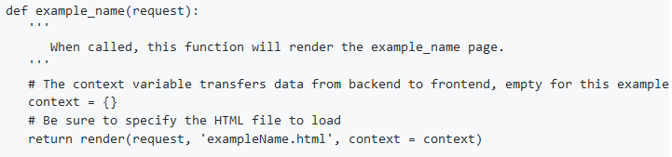

* + - 1. Modify urls.py

Now we need to let Django know where our web page will be. In urls.py, there is a list variable called "urlpatterns". We will need to add an additional path() argument into the variable.

* The first variable is
* The second variable is the path to where the function we made in views.py is. In this instance it would be "views.example_name".
* The last variable is the name we will give let Django know we want to render the web page.

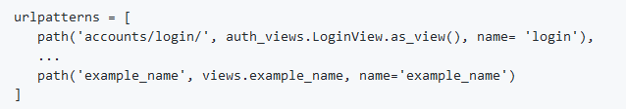

* + - 1. Connecting the existing web pages to the new one
         * Modify index.html or indexLogged.html

There are two areas where we can add this new web page. If you want it to be accessible to users before they are logged in, index.html will need to be modified. If you want this web page to be accessible to users after they are logged in, indexLogged.html will have to be updated. In either case, the process is relatively similar. In the following example, we'll be modifying indexLogged.html. Near the center of the indexLogged.html file, there is a series of lines containing Django template language. It should look something like:

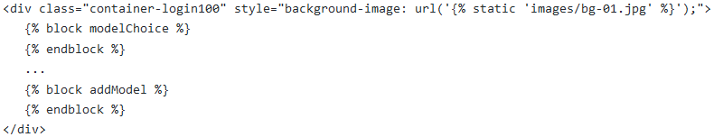

In the example above, "{% block modelChoice %}" references a placeholder for the contents of the HTML file called modelChoice.html. The name after "block" doesn't really matter, as long as it's consistent with the name we provide in the HTML we will create in a later step. If we want to create a new web page for the example_name elements we made in the other files, we will first have to create a new block placeholder:

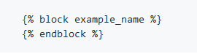

* + - * + Create the new HTML web page: example_name.html

The HTML page we're about to create is different from normal HTML pages because it resembles a chunk of HTML code that would be inside of another HTML file. There isn't a need to define HTML attributes unless you're working on one of the outer layer HTML files such as index.html. To create our new page, we'll need to create an HTML file called example_name.html. The contents of this file are as follows:

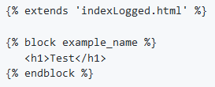

"{% extends 'indexLogged.html' %}" tells Django where to insert this webpage and expand its contents into. We should be using the same name after "block" that we did in the indexLogged.html file. Only the contents of the "block" and "endblock" tag will be displayed on the webpage. At the end of this guide, the text "Test" should be visible on the web page.

* + - * + Making a link to the webpage from an existing web page

Now we need a link on an existing web page to bring us to our new page. We can go to modelChoice.html to add the code needed to do this. Inside the block and endblock tags we'll insert a button that will bring us to the new page.

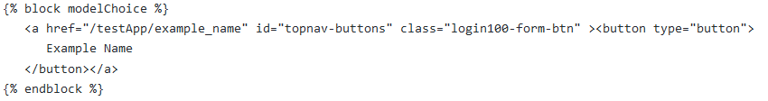

Reload the page and there should be a button labeled "Example Name" on the home screen after you log in that will take you to the new web page that says "Test".

## **Mobile Support**

### Important Concepts

#### CSS Media Rules

An important CSS concept that needs to be understood before tinkering with our implementation of mobile support are media rules. These basically tell CSS which style to apply to a webpage for different media devices. An example would be:

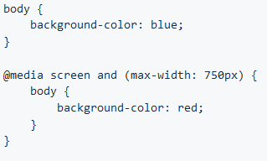

In this example, if the screen size of your device is less than 750px, the background of the page will be red. If it is greater than that, the background will be blue.

#### Bootstrap

Bootstrap helped us tremendously with allowing our website to support various screen sizes. Almost every page as of writing this uses it. We wrote a guide about how we implemented Bootstrap [here](https://medium.com/@fiqriismail/how-to-setup-apache-mysql-and-php-in-linux-subsystem-for-windows-10-e03e67afe6ee).

### Implementation

Not going to lie, but we made a mess into a slightly bigger mess with our CSS files. Well, at least for the ones that aren't Bootstrap.

For the ones that aren't Bootstrap, we used the @media rule approach. The main media rule we used was max-width: 767.98px:

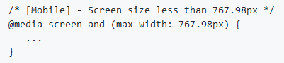

This is the threshold in which we decided that any device below would be treated as a mobile device. Anything not inside this media rule is for screens larger than 767.98px like laptops and desktops. There are other media rules for specific sizes but those are mostly in main.css.

If there's a bright side to all of this, it would be that most elements already adjust to various screen sizes because of the Bootstrap elements that we implemented throughout our site.

The only media rules that you need to worry about would be things that aren't Bootstrap like the canvas displaying the pathway and the container with all the reaction variables/controllers in moduleEdit.html and modelEdit.html.

### Helpful Resources

* [w3schools media rule guide](https://www.w3schools.com/cssref/css3_pr_mediaquery.asp)
* [Mozilla's media rule guid](https://developer.mozilla.org/en-US/docs/Learn/CSS/CSS_layout/Media_queries)
* [Bootstrap documentation](https://getbootstrap.com/docs/4.1/getting-started/introduction/)

## **Google Sign in**

Tutorial Used:

<https://www.section.io/engineering-education/django-google-oauth/>

Authorization Tools Used:

* OAuth:
  + <https://django-oauth-toolkit.readthedocs.io/en/latest/>
* BasicAuth:
  + <https://pypi.org/project/django-basicauth/>
* AllAuth:
  + <https://django-allauth.readthedocs.io/en/latest/installation.html>
  + <https://django-allauth.readthedocs.io/en/latest/>
  + SocialAuth:
    - <https://python-social-auth.readthedocs.io/en/latest/>

OAuth V.S. BasicAuth:

* <https://www.nylas.com/blog/microsoft-basic-auth-vs-microsoft-oauth/?gclid=Cj0KCQjwvYSEBhDjARIsAJMn0ljfa5-hK5TSf5yXqsTbX01RhRXpijzFwhNdoi7jvFgqaG6m_OBCOvEaAlOQEALw_wcB>

So, Why AllAuth?:

The way authorization is set up on the website is using basic authorization which uses a username and password to authenticate a user. Oauth which is used for google sign in and other types of social login uses keys without needing to know the usernames and passwords of the user to validate identity. In order to allow both types of authentication, we use Django Allauth. In doing so, we are able to use both basic authorization and key authorization that google uses. Additionally, in order to use google sign in, we need an app known as social authorization which is an additional part of AllAuth. So, AllAuth is an all encompassing tool that allows us to use google sign in.

The Dreaded “Internal Server Error 500”:

When we were first setting up the website on the AWS server, we were receiving an “Internal Server Error” when we were adding “allauth” to installed apps in settings.py. In trouble shooting this error, we looked at the resources below.

Troubleshooting resources:

* [https://stackoverflow.com/questions/52094338/internal-server-error-in-django-and-uwsgi-nginx](https://nam11.safelinks.protection.outlook.com/?url=https%3A%2F%2Fstackoverflow.com%2Fquestions%2F52094338%2Finternal-server-error-in-django-and-uwsgi-nginx&data=04%7C01%7Cbclark5%40zagmail.gonzaga.edu%7C31159a05d1ca4ed43e8e08d8f7d2f031%7C2ba334075ccc4940bd16ae154f04c3ca%7C1%7C0%7C637531832650569257%7CUnknown%7CTWFpbGZsb3d8eyJWIjoiMC4wLjAwMDAiLCJQIjoiV2luMzIiLCJBTiI6Ik1haWwiLCJXVCI6Mn0%3D%7C1000&sdata=WOZxYz64ROXQmEU7192%2F1MiJTIgBVDw%2FKLRu%2B13HlbY%3D&reserved=0)
* [https://stackoverflow.com/questions/38194371/500-error-from-allauth-when-moving-django-app-from-local-to-production](https://nam11.safelinks.protection.outlook.com/?url=https%3A%2F%2Fstackoverflow.com%2Fquestions%2F38194371%2F500-error-from-allauth-when-moving-django-app-from-local-to-production&data=04%7C01%7Cbclark5%40zagmail.gonzaga.edu%7C31159a05d1ca4ed43e8e08d8f7d2f031%7C2ba334075ccc4940bd16ae154f04c3ca%7C1%7C0%7C637531832650579244%7CUnknown%7CTWFpbGZsb3d8eyJWIjoiMC4wLjAwMDAiLCJQIjoiV2luMzIiLCJBTiI6Ik1haWwiLCJXVCI6Mn0%3D%7C1000&sdata=q3q0r2hDuIaBoeAJQt6Syr72LHu4qXf%2FZYtEtqIbqIw%3D&reserved=0)
* [https://github.com/Tivix/django-rest-auth/issues/497](https://nam11.safelinks.protection.outlook.com/?url=https%3A%2F%2Fgithub.com%2FTivix%2Fdjango-rest-auth%2Fissues%2F497&data=04%7C01%7Cbclark5%40zagmail.gonzaga.edu%7C31159a05d1ca4ed43e8e08d8f7d2f031%7C2ba334075ccc4940bd16ae154f04c3ca%7C1%7C0%7C637531832650579244%7CUnknown%7CTWFpbGZsb3d8eyJWIjoiMC4wLjAwMDAiLCJQIjoiV2luMzIiLCJBTiI6Ik1haWwiLCJXVCI6Mn0%3D%7C1000&sdata=KcB1T0vZ0svBp2wY%2BUb36WcMrzcWASTYu09uBHr7tow%3D&reserved=0)
* [http://net-informations.com/q/mis/500.html](https://nam11.safelinks.protection.outlook.com/?url=http%3A%2F%2Fnet-informations.com%2Fq%2Fmis%2F500.html&data=04%7C01%7Cbclark5%40zagmail.gonzaga.edu%7C31159a05d1ca4ed43e8e08d8f7d2f031%7C2ba334075ccc4940bd16ae154f04c3ca%7C1%7C0%7C637531832650589241%7CUnknown%7CTWFpbGZsb3d8eyJWIjoiMC4wLjAwMDAiLCJQIjoiV2luMzIiLCJBTiI6Ik1haWwiLCJXVCI6Mn0%3D%7C1000&sdata=MqYz4tTmYyU%2FDg5N237m9RGqv%2BjailQla6g36Gb5vtg%3D&reserved=0)

Throughout the research and troubleshooting we did, we had multiple different thoughts of why this error might be occurring. One of the first thoughts was that the server was not recognizing “allauth” or that we were using an incompatible version. In order to test this hypothesis, we attempted deleting allauth and reinstalling it in different versions.

Another one of our thoughts was that it had something to do with the fact that we are using NGINX and Django, and tried to see if allauth was incompatible with NGINX. This is not the case.

In the end, we discovered that it was that the static files directory was being overwritten making the server not have access to the necessary files. If this issue occurs again, start by running the command: “sudo python3 manage.py collectstatic” and restart the server. If this does not work, look at the resources that were included in this section to see if one of those will fix the issue.

How to Sign In:

1. Navigate to mybiopath.com. Click the “Login” button. You will be redirected to the login page.

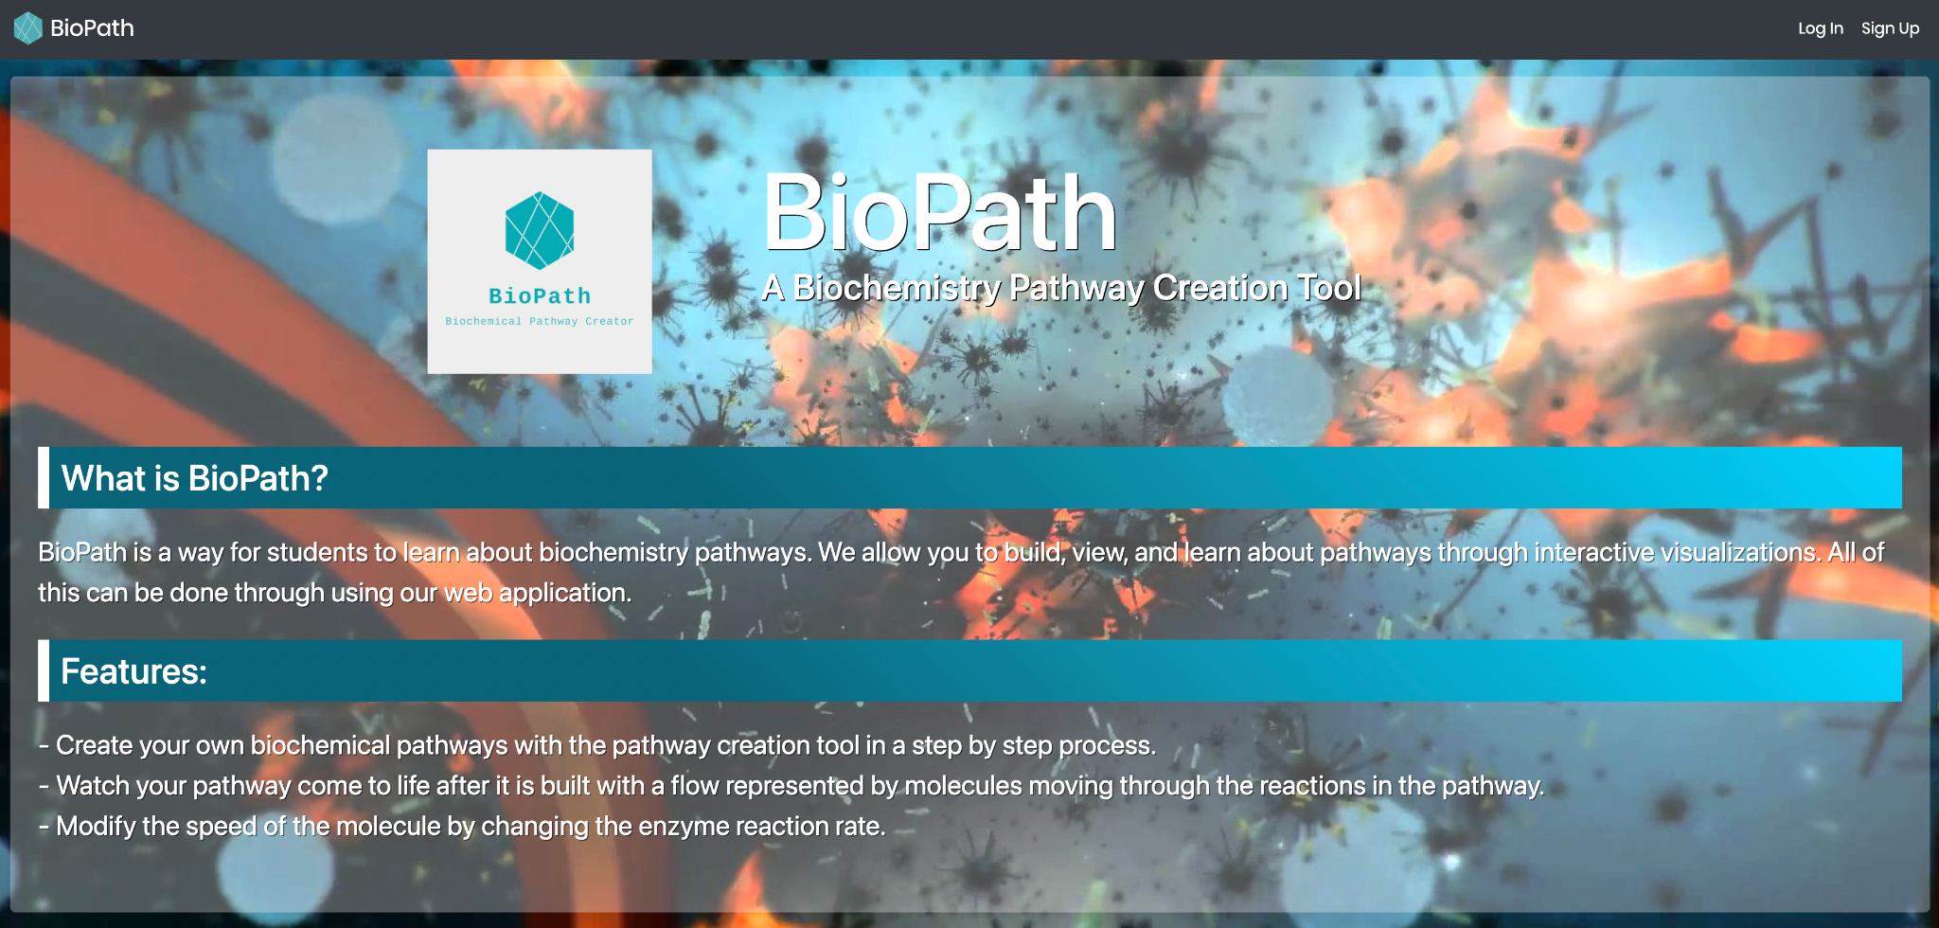

1. Click the google sign in button text.

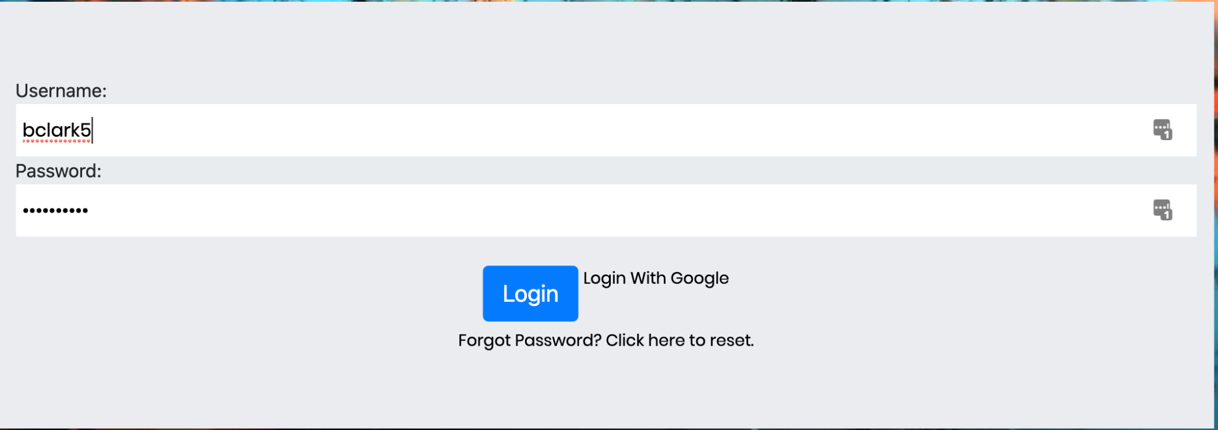

1. Select the account you want to login with. Or, add another account.

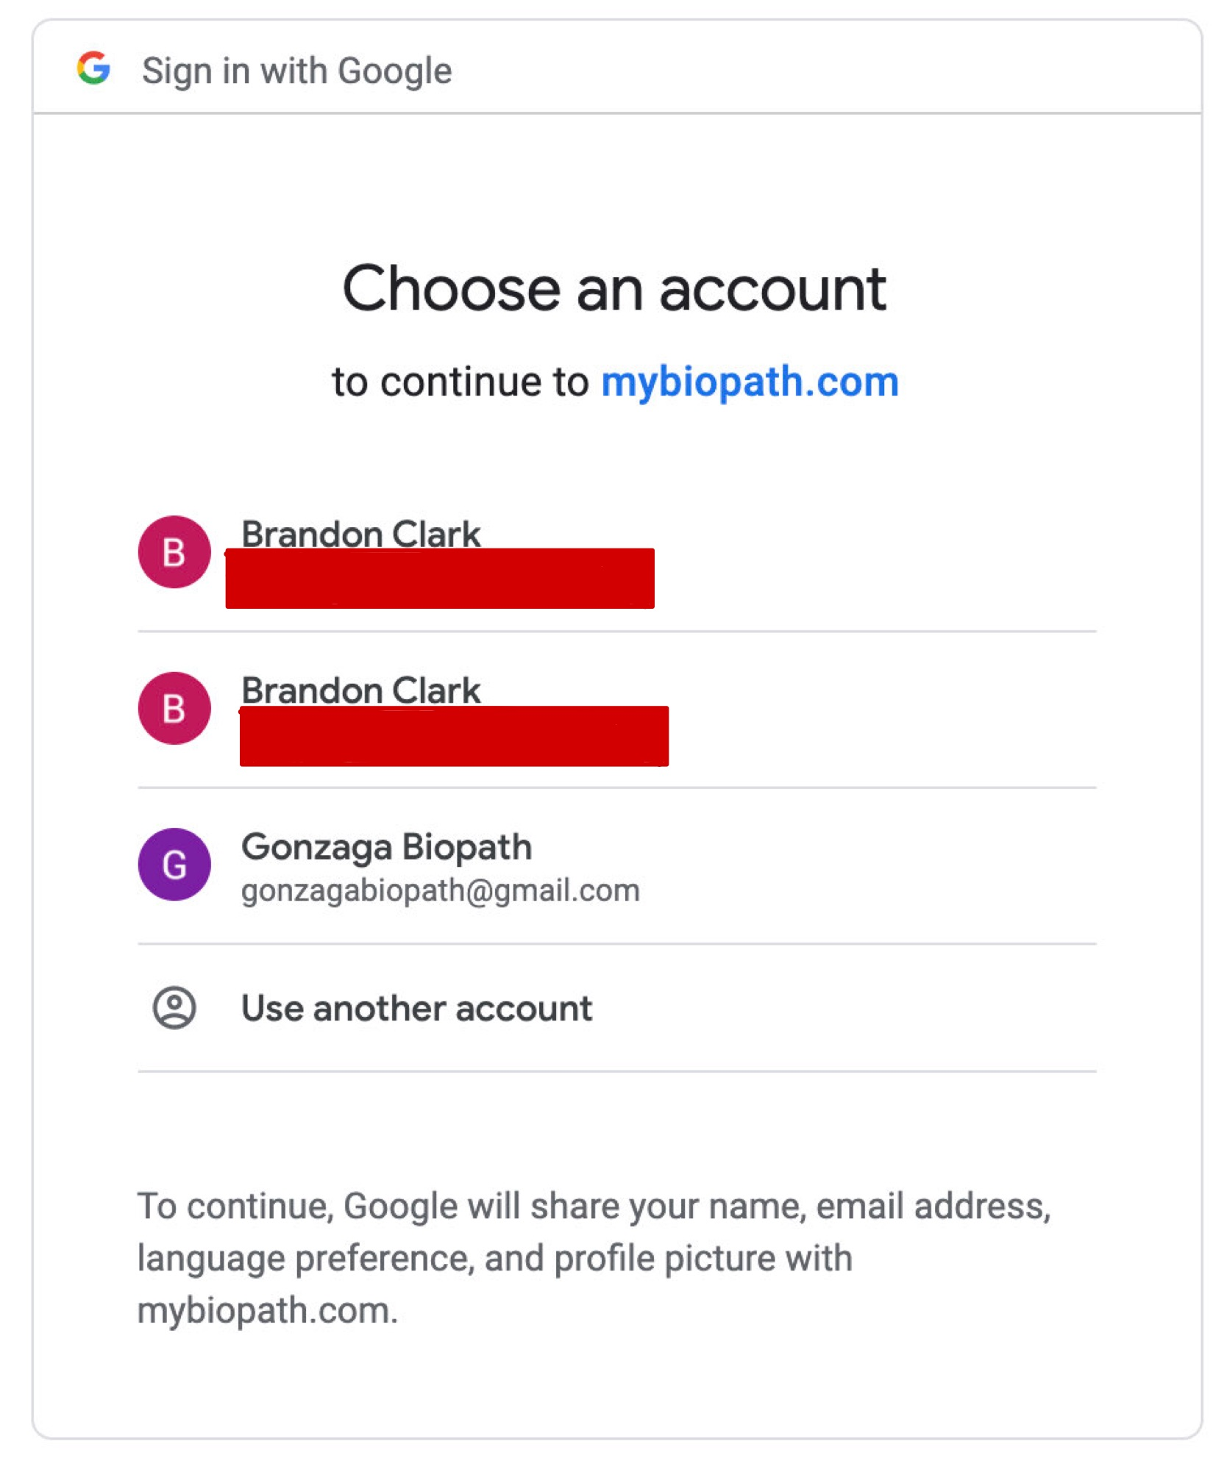

1. If this is your first time logging in with your gmail, you will be prompted to create a username.

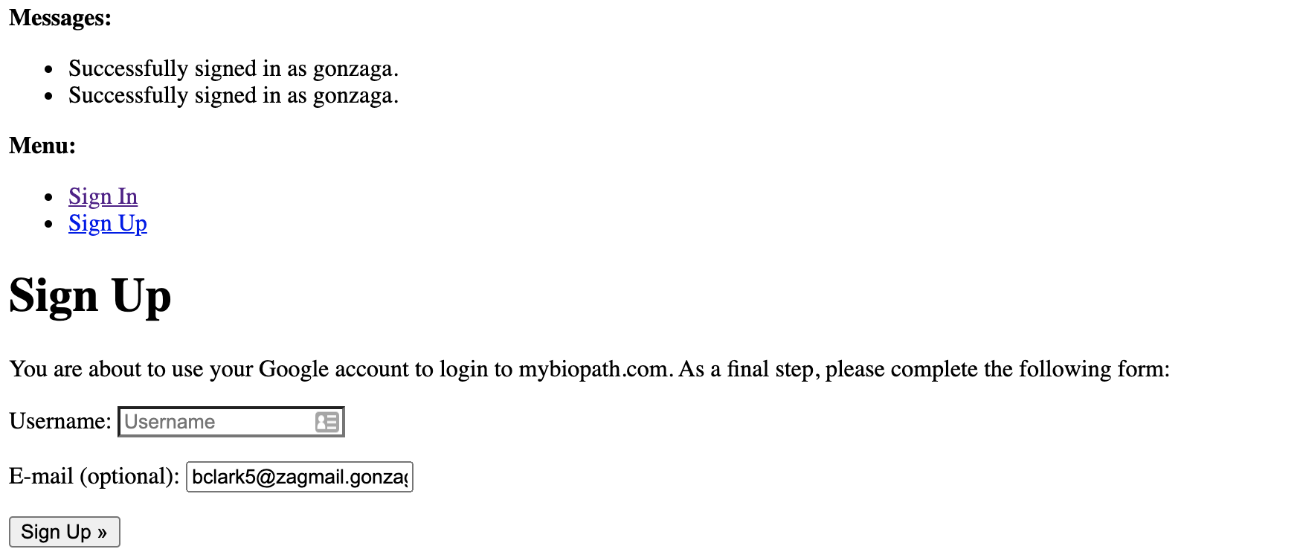

1. Enjoy!

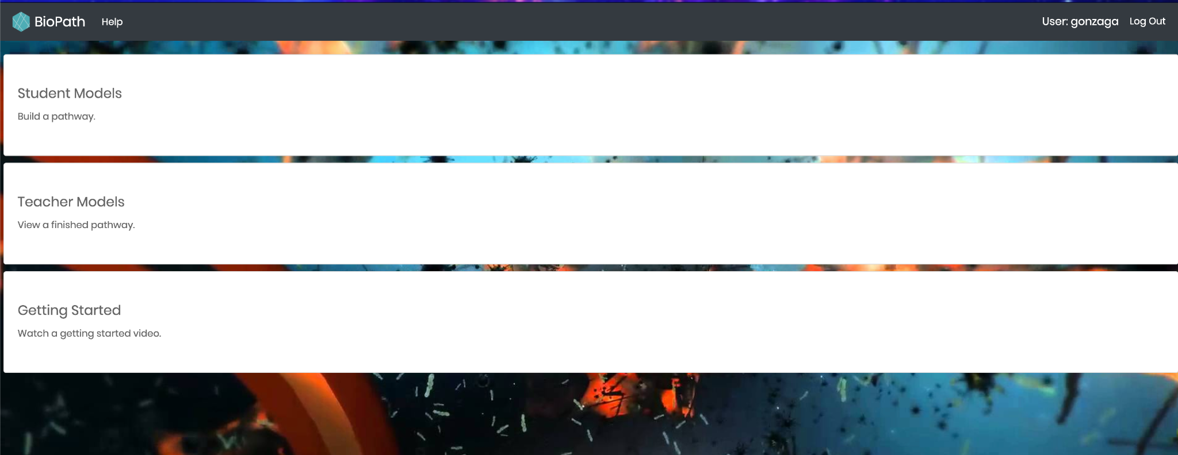

# modelEdit.js

The following documentation is aimed at aiding future developers in understanding how the website draws pathways to the webpage.

## Summary

This file controls how pathways are drawn on the canvas in the modelEdit webpage. The first thing you’ll notice about it is the length. All animations for the canvas are done here. If you want to improve visuals or animations, this is the place to start. Essentially the code keeps track of each product, substrate, enzyme, and dot in various arrays. It gets information about the products, substrates, and enzymes from the webpage. This is the only way to get information from Django to JavaScript (that we know of). Each time the page wants to update the position of the dots, render is called. Based on if the enzyme is a reversible or irreversible reaction, the appropriate function will be called. GetDotPos is used to determine where the dots are drawn on the screen (the dots represent the substrates/products as they flow through the pathway). There are various comments throughout the code with hints on editing it.

## Data Fields (in order of appearance)

* firstRectMidX, firstRectMidY
  + These variables is used when drawing the pathways to anchor all coordinates at the center of the first substrate’s rectangle.
* canvas
  + This is a reference to the webpage’s canvas
* modelDiv, divWidth, context:
  + These are all unused later in the code but were never removed. You can probably remove these, but be careful.
* positionChange
  + This variable determines how far the dots will move between animation frames. Adjust the value up or down to change the speed the dots move
* · prevPosChange
  + This is used to keep track of positionChanged. See playPauseCanvas for more details
* The following arrays keep track of various information for each of the enzymes (modules). The enzyme at index i will be associated with the substrate, product, and reversibility at index i in their respective lists.
  + enzymeList
    - A list of all the enzyme abbreviations (from db_modules)
  + substrateList
    - A list of all the substrates
  + productList
    - A list of the products
  + revList
    - A list of whether an enzyme is reversible or not
  + xCoords
    - The x position of the enzyme in the pathway
    - Used when determining where to draw elements of the enzyme
  + yCoords
    - The y position of the enzyme in the pathway
    - Used when determining where to draw elements of the enzyme
* dotPositions
  + The list that keeps track of each of the blue dots on the canvas
* directions, rxnDir
  + The lists that keeps track of the directions the dots are going (either forward or reverse)
* prodSubValues
  + The list to keep track of how “full” each enzyme is.
  + Ask Dr. Watson about the river dam representation if you don’t know what this means
* kValues
  + The list that holds the k values for each enzyme. This would be used to create more accurate calculations, although it is not implemented anywhere in the code.
* hightlightRects
  + The coordinates that each of the rectangles for the substrates and products should be drawn at, as well as the width and height.
* The following lists are passed to the javascript through the html using the Django template language. See modelEdit in views.py for where these are getting the information from originally
  + db_modules
    - Information about each of the enzymes from the database
  + db_substrates
    - Information about each of the substrates from the database
  + db_products
    - Information about each of the products from the database
  + modelNum
    - The specific id for the current model (pathway)
  + xCoorNext
    - The x-coordinate for the next enzyme
    - This comes from navigating back from moduleEdit.html
  + yCoorNext
    - The y-coordinate for the next enzyme
    - This comes from navigating back from moduleEdit.html
  + pubModel
    - A Boolean to say if the model is public or not
* sliders
  + An unused array, can probably be safely removed but use caution
* paused
  + A Boolean to determine if the pathway is currently paused
* subProdImage
  + An image used when testing drawing sprites to the canvas instead of dots.
  + Can be safely removed or used to change the blue dot into something else
* playPauseButton
  + The button from the webpage that controls if the pathway should be paused or not

## Functions

* · playPauseCanvas
  + This function is the event listener for playPauseButton.
  + It pauses the pathway by setting positionChange to 0
  + It resumes the canvas by setting positionChange to prevPosChange
* notRevStep
  + This function draws irreversible steps to the canvas
  + Towards the top are some comments on how to potentially add cofactors to the reaction. There are other sections of code commented out to draw various things for that such as arrows and the abbreviations.
  + Essentially each module is drawn out “by hand” by calling a bunch of canvas draw commands.
    - You will need to learn or know how these work before editing this function. Otherwise you will have a very confusing and frustrating time.
* revStep
  + Essentially the same as notRevStep, but for reversible reactions.
  + No work was done into adding cofactors into these reactions. Ask Dr. Watson if cofactors in reversible reactions are even a thing.
  + This function also draws the reactions through a series of canvas draw commands. Learn them or what they do before trying to edit.
* calculateX
  + This function is used to calculate the center of the circular arcs in the arrows of the irreversible reactions.
* checkRatio
  + This function checks to see if a reaction is “full”. Ask Dr. Jeff about the river dam model if you don’t know what this means.
    - If the reaction is full, change the direction the dots go
    - Otherwise keep the dots going forward.
* getDotPos
  + This function determines the position of each of the dots in the pathway.
  + It is a very confusing and cluttered function, but also vitally important, so edit it with care.
  + A lot of the if/else branches could probably be consolidated, but we decided it was not worth our effort to do that this year.
* animate
  + This function is called to animate the pathway on each new animation frame
* render
  + This function goes through all the enzymes and calls notRevStep or revStep based on if they’re reversible or not.
* convertIdToText
  + This function converts a module id to text by replacing the underscores with a space
* convertTextToId
  + This function converts a module id back to an id by replacing the spaces with underscores
* calculateK
  + This function is currently unused, but would be where you would start to implement more realistic calculations.
* deleteValues
  + This function is unused anywhere and can probably be safely deleted if you don’t use it in the future
* reset
  + This function goes through and resets or recreates various elements of the webpage and code
* parseThough
  + This function is never called anywhere, it could probably be safely deleted unless you find a use for it.
* addValues
  + This function populates many of the various arrays in the code
* redirect
  + This function builds the proper url for creating a new module
* createSliders
  + This function creates the sliders used to determine the rates that irreversible reactions run at
* calculateColor
  + This function determines the color a substrate or product should be.
  + If it is almost “full” it will be orange
  + If it is full, the color will be red
  + If you don’t know what “full” means, ask Dr. Watson about the river dam model.
* main
  + The function that’s called when the page loads. It calls the functions essential for the page to run

# Current Bugs

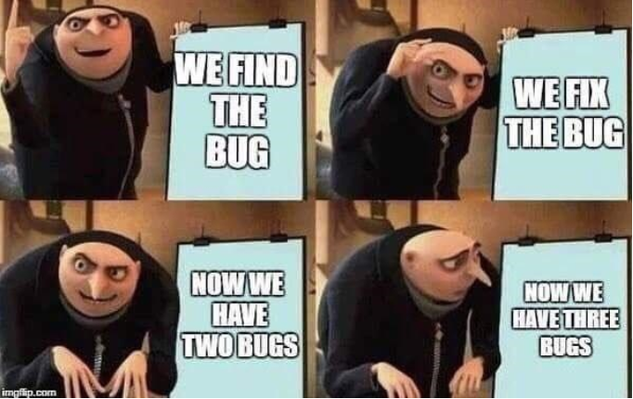

## Mobile to Desktop mode in a web browser

These aren’t important bugs to try and fix for the user. More annoyances on the developer side of things.

* + - 1. Going from mobile to desktop mode in the modelEdit and moduleEdit page with the sidebar open uncenters the page content such as the canvas. This is a minor bug that has to do with the way we set up media rules to change the layout of the page when on a mobile device.
      2. Going from mobile mode to desktop with the moduleEdit sidebar open, the canvas disappears.

## Scaling of Images

Images in the moduleEdit canvas do not scale perfectly and instead become distorted at certain sizes. This bug might have to be fixed using a JavaScript listener, as CSS changes to the canvas distort the content.

## Pathways (drawPathway.js/Molecule.js)

A big bug in circular pathways is how cofactors are drawn to the screen. One of the first things we’d recommend the next development team work on is adding a “cofactors” section to the website. For example, when a user adds a reaction to a pathway they should be able to add substrates, enzymes, products, and cofactors. Then, the values (like ADP) will be stored separately in the database. Right now, cofactors are hard coded into the code for both linear and circular pathways. This creates some bugs when the number of reactions is manipulated.

Currently, the reaction between DHAP and GADP is not drawing to the screen. In other words, the function linRevHorizontal() is not working properly. This is causing the enzymes later in the reaction to be drawn incorrectly. Fixing this test case scenario should bring Glycolysis back to its completed state.

Currently, the molecules being drawn running through a circular pathway stops at the very last reaction. Meaning, the molecules don’t continue moving through the pathway; they stop at the second to last reaction.

## Zooming

Currently, when you use the zoom in/out buttons, each product/substrate has a molecule that stops moving. Our team is not sure why this bug is occurring. Double the molecules are made, and one of the sets is being updated. We don’t know what is causing this or why. Bootstrap also needs to be updated to accommodate zoom. If you look at the dotPos list before and after zooming you will see that the length has doubled.

## Front End

The Front end (Nginx) is working, though we are unsure why. The symbolic links for the init files are broken yet somehow Nginx is still working on startup. It is possible that it save the files someplace else somehow.

The name for the log file for Nginx broke because the line before it in the configuration file had the massive path name of cpsc-491-2-senior-project-biopath-tools-for-biochemistry which spanned multiple lines. The log file is in biopathadmin’s home directory under cpsc-491-2-senior-project-biopath-tools-for-biochemis

Resources used for connecting Nginx and Django:

[How to Set Up Django on Nginx with uWSGI - Tony Teaches Tech](https://tonyteaches.tech/django-nginx-uwsgi-tutorial/)

[7 Critical Django Production Server Settings to Configure Before Going Live - Tony Teaches Tech](https://tonyteaches.tech/django-production-server-settings/)

^^ Tony was very useful in setting up our Front End, without him we would have much more time spinning our tires. Watch his videos to understand how we set this up. He is also very active in answering questions on both his youtube videos and his website so if you have any issues, ask him.

## Other

The Model Choice page used to contain a list of each template and each student attempt at a pathway, hence its name. Since we changed its functionality to instead have buttons that redirect to other pages, the name is no longer fitting.

The way the database is currently setup is not very efficient and allows for a lot of redundancy or conflicts. We decided we did not have the time in our schedule to go back and fix it, so we just worked with how it was. For example, instead of storing the information about glycolysis once, we store it once for the public pathway and then once for each user that joins our application so they can attempt it. Instead of storing glucose once in the database, we store it once for each time it appears in a pathway for each user and for the public pathway.

# Future Work (Suggestions)

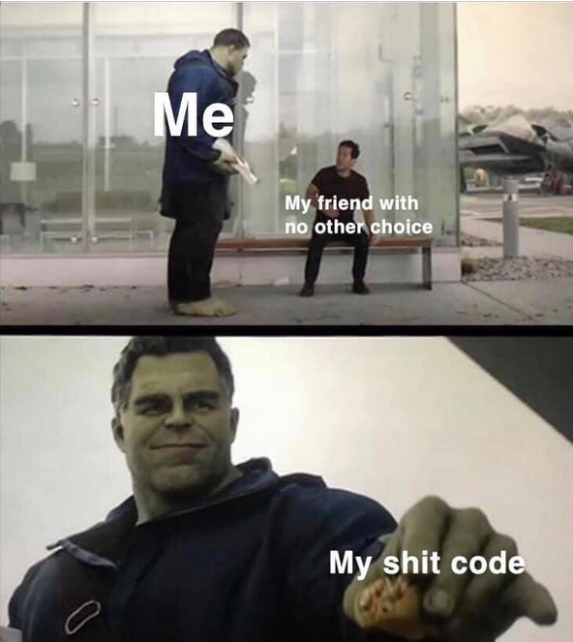

~~----------------------------~~

US

~~----------------------------~~

You

Our Bad*

*We are a Catholic institution. No swearing

The following list are features that we either did not have the time to develop or thought of during development. They can act as a good starting point for future development on the application. This list includes some suggestions from the group before us that we never got around to or decided were not a priority.

The following are NOT in any particular order.

## Graphics

* + - 1. Have 2 molecules (blue dots) appear parallel on the canvas on the ModelEdit screen
         1. Currently on the ModelEdit screen you can see molecules flowing through the pathway. As the molecules traverse the pathway and the rates of each reaction change, the molecules sometimes end up going back up the pathway. This is only possible for reversible reactions. However it may be beneficial to display to the user when the molecules go backwards by showing a parallel path of molecules going the opposite direction. This would signify to the user a more accurate representation of the simultaneous reactions occurring.
      2. Search function on ModuleEdit screen
         1. Currently on the module edit screen there is a list of products, substrates and enzymes for the user to scroll through and pick from. A potential improvement could be to display a text box above the product, substrate and enzyme lists that would allow a user to filter and search through each of the lists. This may make it easier for a user to find a specific product, enzyme or substrate they are looking for.
      3. Improve the visuals of the pathways
         1. Currently most elements of a pathway are just text and basic shapes. The application would become much more appealing if those were swapped out for more realistic depictions.
         2. Possible additions to this we discussed would be some sort of toggle between the realistic and simplistic graphics, in case the realistic ones were too abstract to learn from. This would likely involve changing up how most of modelEdit.js is written, as that is where the pathway drawing code is currently living. (See the modelEdit.js document for a rundown of what is in that file)

Make the display of the pathways look better: add shading, make it 3D, I dunno, just make it look beautiful.

## Pathways

Add an indicator to show how far a student is in completing a pathway: backend way of doing this would be to have $\frac{number reactions student has completed}{number total reactions for pathway} x 100$

Add the ability to display reactions that have more than one non-cofactor substrate or product.

Currently, the code will only display one substrate for a reaction in a pathway. So if you had G6P and Glycolysis as substrates it would only display one.

Redo the UI of adding a pathway to the database to incorporate the bootstrap code. (addModel code currently just has it’s own css file)

Fix the hardcode that renders all irreversible reactions with ATP and ADP. Additionally, look at 4.

Add the ability to build reactions with cofactors

Some reactions have additional substrates and products on top of the main ones they use and produce. The first enzyme in glycolysis, hexokinase, is an example of one such reaction. When you view glycolysis, notice the ATP and ADP on the right of the enzyme. There is no way to customize what those cofactor abbreviations are or how many there are in the reaction. A possible fix would be an additional attribute in the products and substrates tables to signify whether a product or substrate should be drawn as a cofactor or not.

Currently, the code draws cofactors on all irreversible reactions. Because cofactors are unlike other substrates or products it might be advantageous to declare this in the database. Cofactors can be on both reversible and irreversible reactions. Cofactors include, but are not limited to, H2O, NAD+, NADH, ATP, ADP

The version of Glycolysis on the website and in the database is incorrect.

Reaction with the enzyme GAPDH should have NAD+ as a substrate and NADH as a product.

Reaction with the enzyme PJK has ADP as the substrate and ATP as the product.

Reaction with the enzyme PK has ADP as the substrate and ATP as the product.

On the add reaction page (addModel) have the ability for adding a reaction wherever one wants to. Currently, one can edit a reaction, but adding a new reaction will always put it as the last one.

Add ability to build diverging pathways

In the example pathway of glycolysis, there is a step where one enzyme produces two substrates. There is no way to create a branching path through the website. It is possible by adding information directly to the tables, but we were not able to figure out how to do that ourselves. Study how the glycolisys model is built within the testApp_module, testApp_model, testApp_products, and testApp_substrates tables.

We weren’t really sure how the database was able to store that information… something with the xCoor and yCoor numbers we think. And we don’t know how it displays it.

Add a comment for when the pathway is complete

Once a user finishes building a complete pathway, a box pops up informing the user that the pathway is complete.

* + - 1. Give hints to the user if they are struggling to find the correct reaction.
         1. On the ModuleEdit screen the user enters data to create a reaction and then gets feedback on whether or not the reaction they enter is correct. A potential improvement would be to determine how close the user is to finding the correct reaction and give them hints for what they are missing or what is incorrect. For example, if the user has the enzyme, products and substrates correct but they say the reaction is reversible when it should be irreversible, a snackbar could pop up letting them know the reaction is irreversible.
         2. Alternatively, if you don’t want a hint to appear everytime they get the reaction wrong, you could implement a hint button so that the hints only appear when the button is clicked.
      2. Add ability to build cycles within a pathway
         1. Some pathways, such as the citric acid cycle (ask Dr. Watson), cycle back on themselves instead of going in a straight path. Adding the ability to represent them within the application would open up many more pathways to be created, and thus the usability of the app would increase. Implementing this feature would likely involve a rework of the database and how pathways are drawn and be a large undertaking. 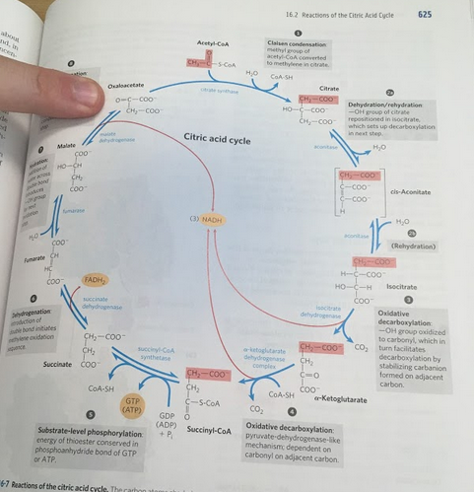
      3. Link pathways
         1. Inside the cell there are thousands of pathways for molecule to traverse. These pathways are linked and they interact with each other. Our website has implemented an isolated Model of pathways. One route for improvement could be to link pathways together. This could give a user a more accurate representation of how the pathways interact. Glycolysis and Gluconeogenesis are technically linked pathways.

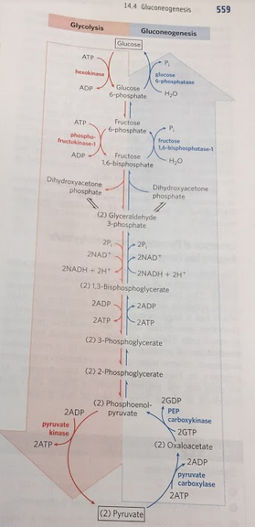

## Database

1. The 2019-2020 Software Developers were not very excited about the design of the database… We talked about reconfiguring it but decided not to because of the amount of code (that we did not entirely understand) we would need to change to be compatible with a new database design.
2. Change the Login information. The current database information is on the 2018-2019 developers PUBLIC github. So, it’s not really that secure :/

## Miscellaneous

1. Allow the user to change password after he/she has logged in. Using the “forgot password” option on sign in doesn’t count
2. New users are automatically added to a group that has a specific set of permissions. TODO: what does this mean?
3. For new admin, have a button asking if you would like to request admin privileges. Automatic email gets sent to superadmin that can approve or deny request.
4. Improve the math
   1. In our website we have provided a simplified implementation of how the molecules travel through a pathway. However, there are different calculations that could be made behind the scenes to more accurately reflect what is going on. You will need to consult Dr. Watson to get the correct formulas in order to add this feature. The changes would be made primarily in modelEdit.js

# BioPath: A History… + resources



It is not always easy to meet with Jeff Watson. Do not be afraid to send multiple emails to him about setting up a meeting time.

## 2018-2019

The Developers: Kaylee Moniz, Garett Palm, Stephen Joyce, Kayla Larson

Their Documents:

* [Weekly Task Sheet](mailto:shrestha@gonzaga.edu?usp=sharing)
* [Project Plan](https://virtualenv.pypa.io/en/latest/?usp=sharing)
* [Project Backlog](https://docs.google.com/spreadsheets/d/1ktY1G7tluKuXQLoiwlncsuEFiD-oRuO-6fFmuu4jT50/edit?usp=sharing)
* [Latest PowerPoint](https://code.visualstudio.com/?usp=sharing)

## 2019-2020 Developers

The SQUAAAAD: Benjamin Bladow, Andrew Broadhead, Joshua Go, Zachary McKee

We alternated the role of “supreme leader” each week for Bryant.

Our Google Drive: The following is a link to our [google drive](https://www.fullstackpython.com/introduction.html)

[https://drive.google.com/drive/u/0/folders/1YzFBX6uo8fa9NjJ49hdpLVI3_ysGl1A2](https://dev.mysql.com/downloads/workbench/)

Make a zip file of our github? Ask Bryant about how to hand off everything. Or public repo?

What about the dump.sql file – SECURITY – emails????

## 2020-2021 Developers

THE O.G. Squad V2 Electric Boogaloo: Brandon Clark, Sean Letts, Hailey Mueller, Daniel Strub

Our google Drive: <https://drive.google.com/drive/folders/1hs6NK4Dx6tUvS-Dojc5E0RIQMkiWRqwt?usp=sharing>

Ask for Zip files from Advisor

# Important Account Information

Accounts

1. Google
   1. username: gonzagabiopath@gmail.com
   2. password: B10Te@m!
2. AWS
   1. Username: gonzagabiopath@gmail.com
   2. password: aws_B10Te@m!